Kristian Stoyanov Belkin, Paul Daniel Pop i Raúl Jiménez Ayza

NIU: 1667799, 1607129 i 1688916

**Proyecto 2 Parte 3 ETIQUETATGE Inteligencia artificial**

Contenido

Introduction 2

Qualitative Analysis Functions 3

Retrieval_by_color: 3

Test 1 4

Test 2 4

Retrieval_by_shape: 5

Test 1 5

Test 2 6

Retrieval_combined: 7

Test 1 7

Test 2 7

Conclusion 8

Quantitative Analysis Functions 8

Get_shape_accuracy: 9

Get_color_accuracy: 9

Kmean_knn_statistics: 10

Improvements or changes to K-means and KNN 11

Centroid Initialization Methods for K-means 11

K-means ++ 12

Random Initialization 13

Pruebas de rendimiento 13

Test 1 13

Test 2 15

Test 3 17

Conclusion 20

Fisher Coeficient 21

Find_BestK: 29

Test 1 33

Test 2 33

Test 3 34

Test 4 34

Test 5 35

Global Conclusions 36

# Introduction

In this second practice, we have the general task of performing automatic labeling of clothing images. Through our code, we should be able to assign labels to different types of clothing (8 in total) with their respective colors (11 in total).

To perform these tasks, we use two files for two algorithms called KNN (K-nearest neighbors) and K-means (K-means clustering). Below, we will explain both algorithms in more detail:

K-means is an unsupervised classification method that we use to generate clusters from the information we have about the colors. This allows us to group the pixels of each image and thus determine the predominant colors.

KNN, unlike K-means, is a supervised classification method that we use to find the type of clothing in each image. It works by searching for the K nearest neighbors and assigns the type based on the majority of the closest neighbors.

# Qualitative Analysis Functions

## Retrieval_by_color:

The function retrieval_by_color is a search tool that allows you to find a series of images based on the color values provided.

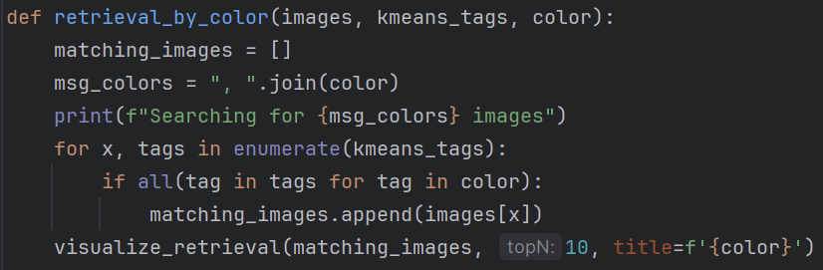*Código de la función*

This function takes the following parameters:

* Images**:** The set of images on which we want to search.
* Kmeans_tags: The color predictions made by the K-means algorithm previously on the set of images.
* Color**:** The color of the images we want to find.

Regarding the code, each sublist within the kmeans_tags list represents the predicted colors for an image. To find the images that contain the color we are looking for, we simply iterate through the kmeans_tags list and check if any color matches the desired color. If so, we save that image.

Next, we will explore some of the results obtained by running the function with different color criteria. For these tests, 1000 images from the training set were used.

### Test 1

Searching for black clothes**:**

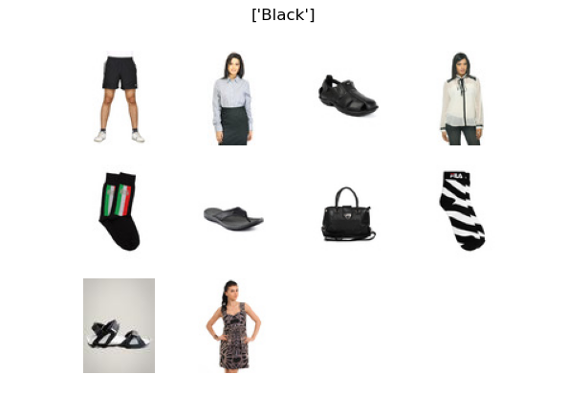

### Test 2

Searching for pink and gray clothes:

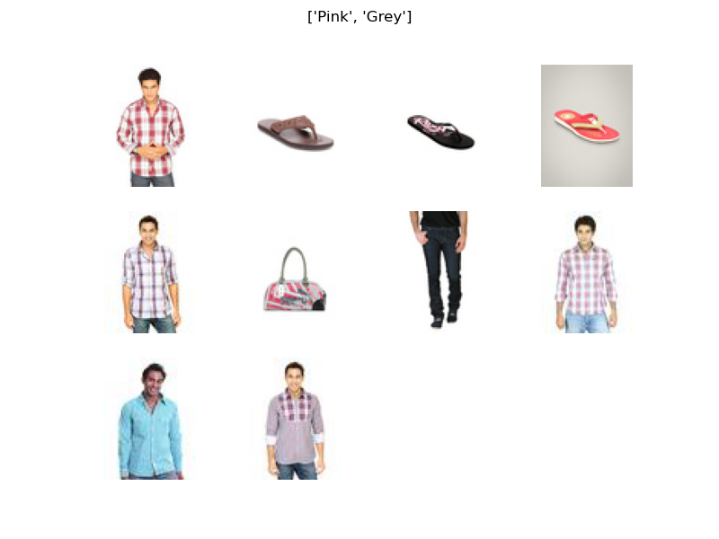

For all these tests, an overall accuracy of 96% has been achieved using the K-means algorithm. However, it should be considered that for certain images, colors such as black, orange, gray, or white may be present in the background of the image, in the person's hair, or in their skin tone. Therefore, in some predictions, certain colors may not be present in the garment.

## Retrieval_by_shape:

The retrieval_by_shape function is very similar to the previously seen function, but in this case, it searches by type of garment instead of by color.

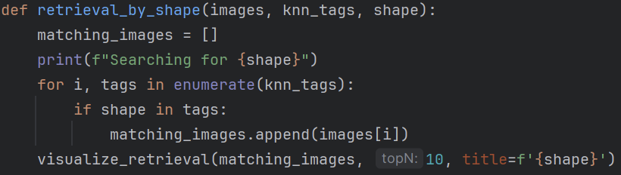*Código de la función*

As before, the function receives as parameters the images to be evaluated, the predictions from the KNN algorithm, and the type of garment we want to find.

Below are the results of running the function on the same set of 1000 images.

### Test 1

Searching for jeans:

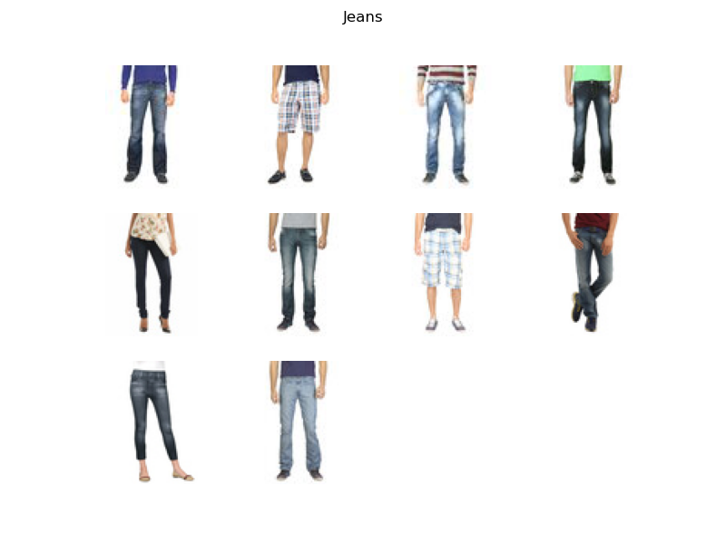

### Test 2

Searching for dresses

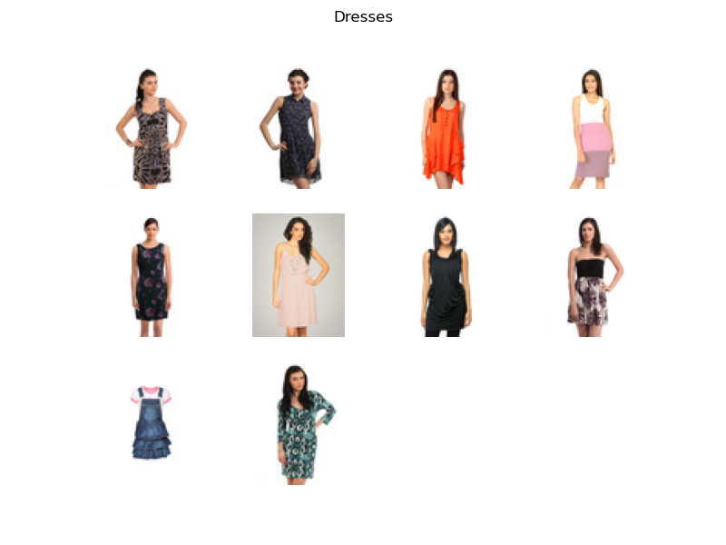

For all these tests, an overall accuracy of 91% has been achieved using the KNN algorithm. In the first test, there were some errors where 2 garments were incorrectly classified as jeans when they were actually shorts. However, in the other tests, the predictions seem quite good. Although the accuracy percentage is lower compared to color classification, visually evaluating the results, it appears that KNN is more precise.

## Retrieval_combined:

The retrieval_combined function is a combination of the two functions previously discussed, allowing for searches by both type of garment and color simultaneously. For this case, we will go straight to the tests conducted.

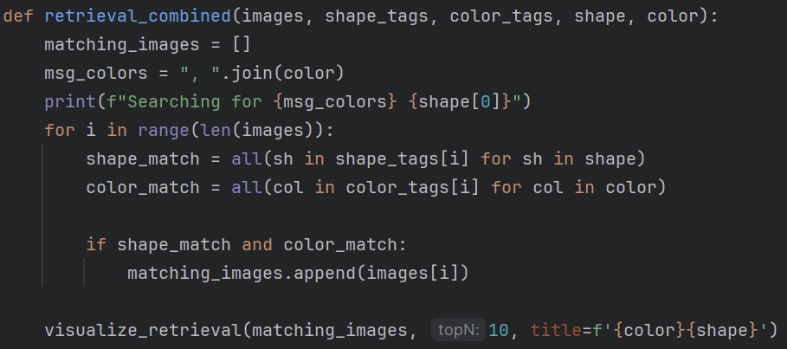

*Código de la función*

### Test 1

Searching for black dresses:

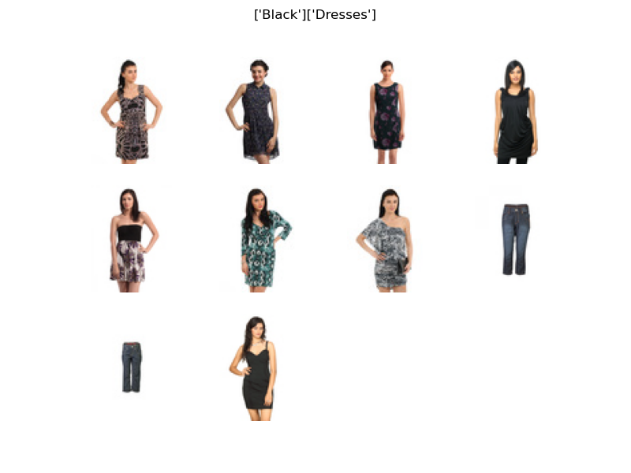

### Test 2

Searching for white and orange shirts:

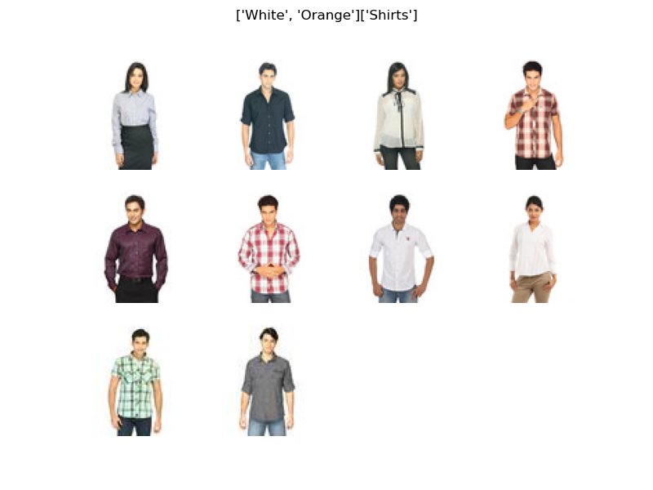

## Conclusion

Observing the results of these qualitative tests, we can conclude that, although the success rate is higher in color classification, the predictions for the type of garment seem to be much more accurate since they do not depend on the color of the image. This is evident when using the retrieval_combined function, where the type of garment is predicted quite well, but the colors are often confused with the skin tones of the models and the background colors of the images.

# Quantitative Analysis Functions

## Get_shape_accuracy:

This function will help us validate the tags obtained from the KNN algorithm.

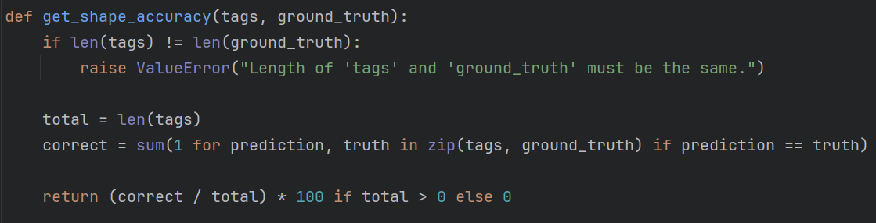

The first thing we do in this function is check that the lists of tags are equal in size. If they are not, we trigger an error. We save the total length to later calculate the percentage, and then proceed to check if the predictions are correct by comparing them with the "ground truth." If the prediction is correct, we increment the number of correct predictions. Finally, we divide the correct predictions by the total and multiply by 100 to give a percentage.

## Get_color_accuracy:

Very similar to the previous function, this one will help us validate the tags obtained from the K-means algorithm.

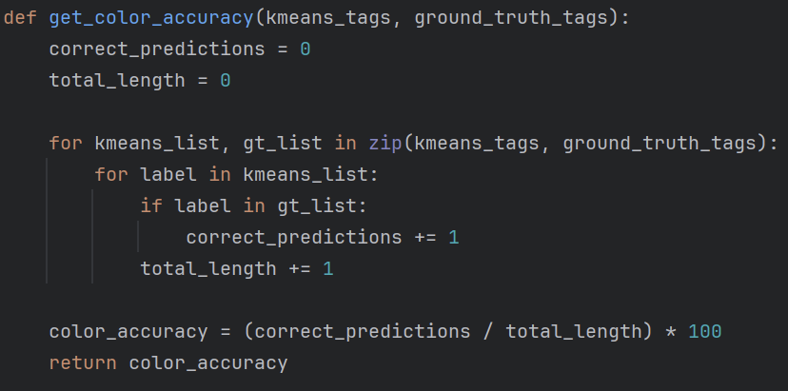

As before, we compare the predicted values with the "ground truth," and if they match, we increase the number of correct predictions and calculate the accuracy value. Both previous functions have been used in qualitative tests to determine the success percentage of the K-means and KNN algorithms. They will also be used in the quantitative function explained below.

## Kmean_knn_statistics:

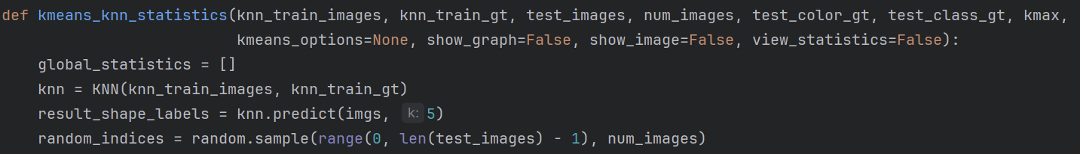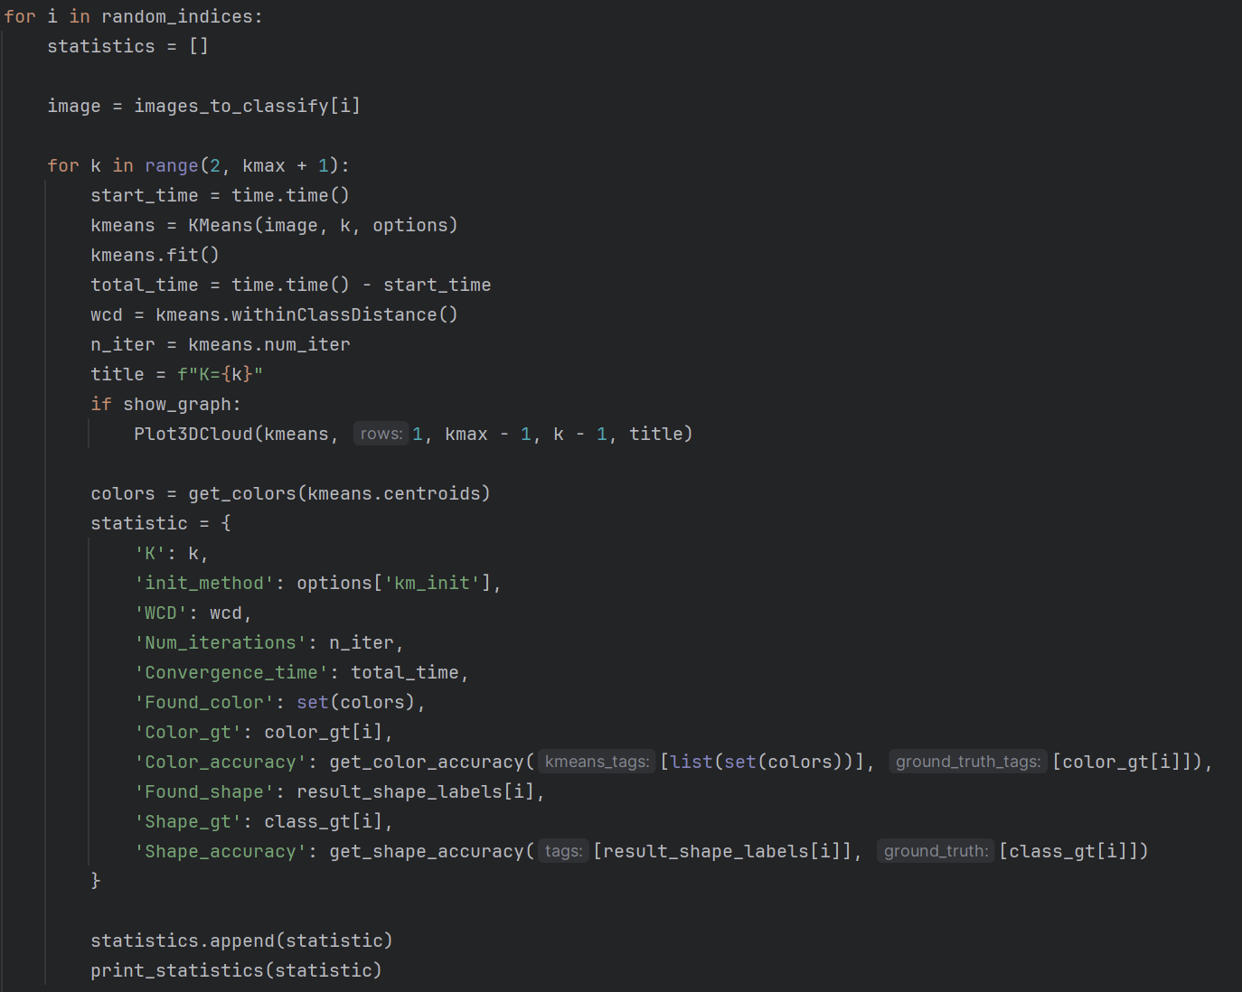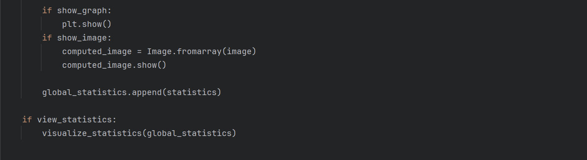

The kmeans_statistics function runs the K-means and KNN algorithms on a set of images to evaluate and compare their performance according to various metrics. Below, the input parameters of the function and the different metrics calculated are described.

**Input Parameters:**

* **Knn_train_images:** Set of training images for the KNN algorithm.
* **Knn_train_gt:** Ground truth labels of the classes corresponding to the training images.
* **Test_images:** Set of images to be classified.
* **Num_images:** Number of images to select randomly for analysis.
* **Test_color_gt:** Ground truth labels of the colors for the images to be classified.
* **Test_class_gt:** Ground truth labels of the type of garment (classes) for the images to be classified.
* **Kmax:** Maximum value of K (number of clusters) to consider in the K-means algorithm.
* **Kmeans_options:** Dictionary with additional options for the initialization and configuration of the K-means algorithm.
* **Show_graph:** Boolean indicating whether 3D graphs of the point clouds should be displayed.
* **Show_image:** Boolean indicating whether the processed images should be displayed.
* **View_statistics:** Boolean indicating whether global statistics should be visualized through graphs.

**Calculated Statistics:**

* **K:** Number of clusters used in K-means.
* **Init_method:** Initialization method used for K-means.
* **WCD:** Within Class Distance, which measures the compactness of the clusters.
* **Num_iterations:** Number of iterations that the K-means algorithm needed to converge.
* **Convergence_time:** Total time (in seconds) taken by the K-means algorithm to converge.
* **Found_color:** Colors found by K-means in the image.
* **Color_gt:** Ground truth colors of the image.
* **Color_accuracy:** Accuracy of the colors found compared to the ground truth colors.
* **Found_shape:** Type of garment (classes) found by the KNN classifier.
* **Shape_gt:** Ground truth classes of the image.
* **Shape_accuracy:** Accuracy of the shapes found compared to the ground truth shapes.

This function will be used in upcoming experiments on the improvements made to the K-means algorithm.

# Improvements or changes to K-means and KNN

These are the different improvements and tests we have proposed for our algorithms:

## Centroid Initialization Methods for K-means

One of the main problems with traditional K-means is its sensitivity to the initialization of the centroids. In our case, the algorithm requires the initial centroids to be chosen in very simple ways, which can lead to suboptimal solutions and high sensitivity to the initialization of these centroids. Moreover, in non-uniform datasets or those representing very different classes in their characteristics, standard K-means can converge to local optima rather than reaching global solutions.

### K-means ++

Therefore, K-means++ is an improvement on the traditional algorithm that specifically addresses issues related to the initialization of centroids. The key to K-means++ is to choose the centroids in a smarter and more effective way to distribute them more uniformly in the feature space.

The main idea is to select the centroids according to a distance-based criterion, thereby initializing the centroids with more separation between them. To achieve this result, the following steps can be followed:

1. **Selection of the first centroid:** A centroid is chosen randomly.
2. **Finding candidates for the next centroid:** For each remaining data point, calculate the distance to the nearest selected centroid so far (e.g., Euclidean distance). After calculating the distances, assign each data point a probability of being selected as the next centroid, where the probability of each point is proportional to the square of the minimum distance found in the previous step.
3. **Selection of the next centroid:** Choose randomly according to the previously calculated probabilities. Thus, points that are farther from the already selected centroids will have a higher probability of being selected as the next centroid.
4. **Repeat until all centroids are selected.**

This is the code to implement K-means++: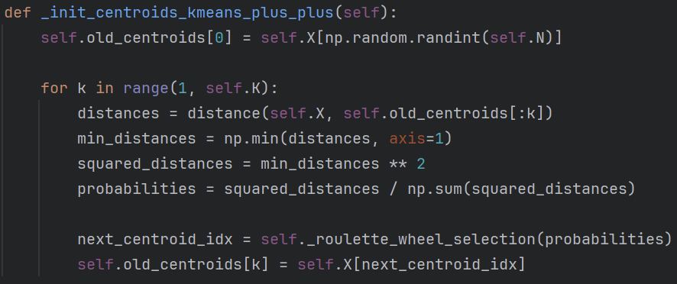

We will also need this function to randomly select the next centroid:

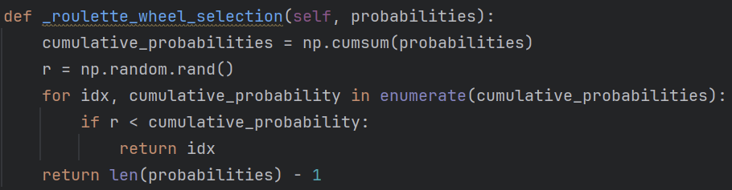

### Random Initialization

Another simpler way to initialize the centroids is to choose random points, you just have to keep in mind not to choose repeated points. This is the code:

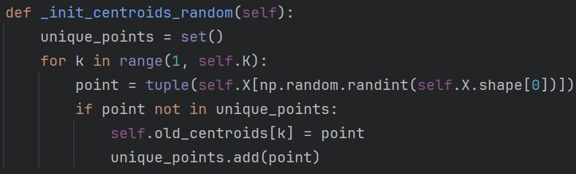

## Pruebas de rendimiento

Next, we are going to carry out some tests that will use the different initialization methods for the K-means algorithm and different sets of images (unmodified images and cropped images) in order to evaluate and compare the performance of our algorithm with the improvements.

### Test 1

In this test we are going to compare the performance of the first, random and k-means++ initialization modes using unmodified images and different values ​​for k. We are going to use 250 random images from the test image set and we are going to see several measurements represented in graphs.

1. **First n points Method:**

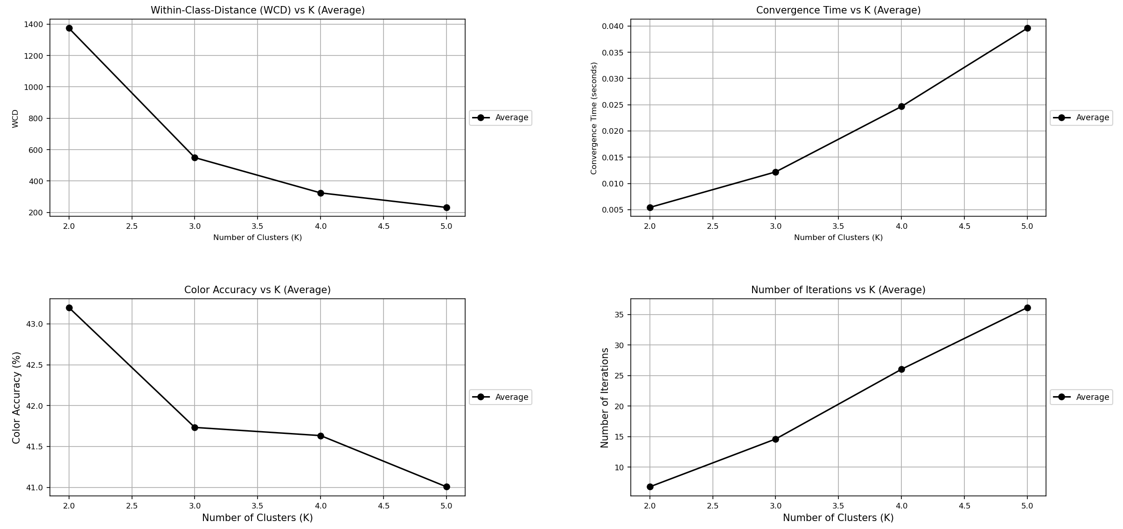

We can observe how for all the images, as the k increases, the average of the WCD decreases and is established in a range of [200,400]. On the other hand, the time to converge and the number of iterations increase for each additional value of k.

Regarding the accuracy rate of the predicted colors, we have the maximum at k = 2, this may be due to the fact that the processed images have 2 main colors. Increasing or decreasing the k in this case causes the K-means algorithm to find more or fewer colors for said image, giving the possibility of finding more colors or not finding all the correct colors, affecting the accuracy rate.

1. **Random Method:**

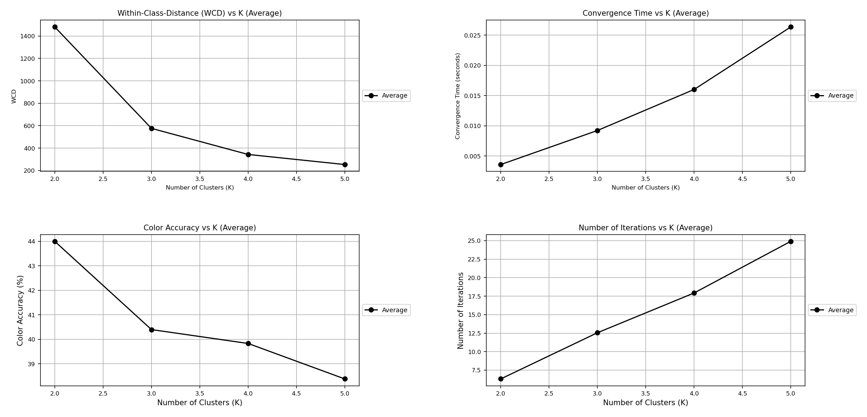

We can see that using random initialization the average WCD and accuracy rate is very similar to using the first method. On the other hand, for k = 5 the convergence time has decreased by 0.015 seconds and the number of iterations has decreased by 10 iterations.

We can observe that using random initialization the average number of iterations and the convergence time decrease, but the average accuracy rate is considerably worse. This may occur because the points are chosen randomly or simply the random images have been predicted worse in this test.

1. **Kmeans++ Method:**

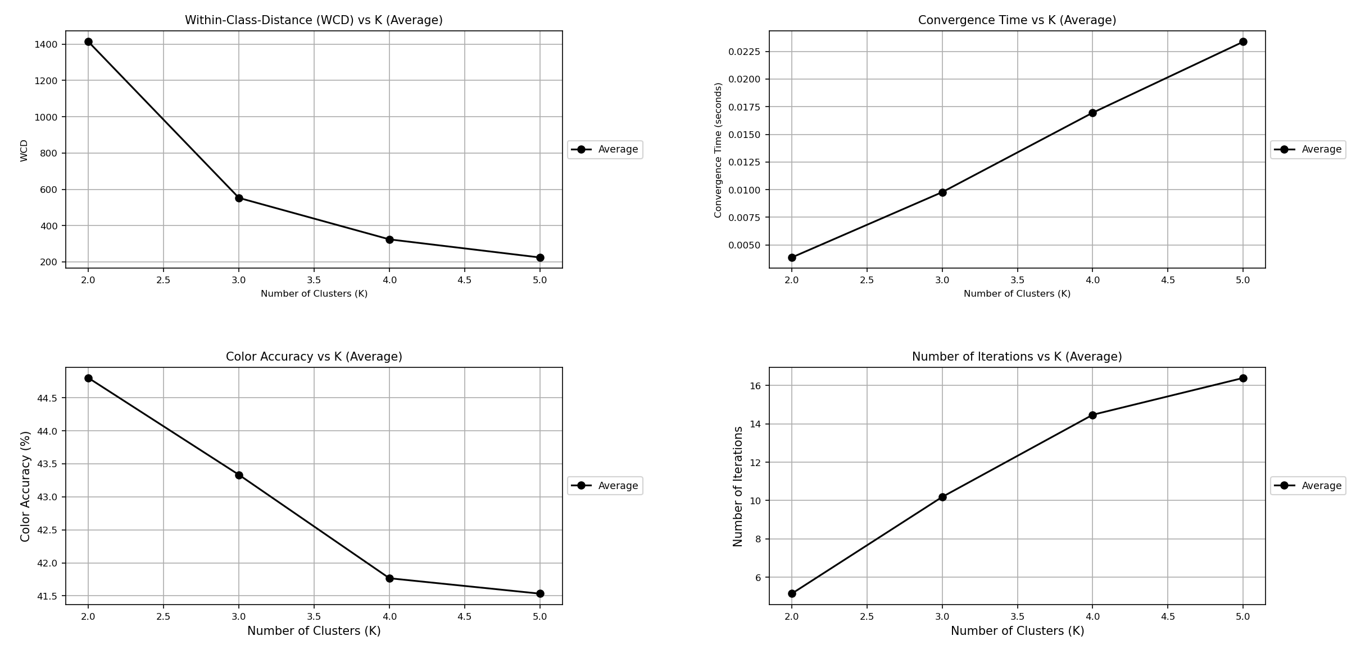

For Kmeans++ the WCD, the convergence time and the number of iterations remain very similar to the random method. You can notice a small improvement in the accuracy rate compared to the random method, but it is not very significant.

### Test 2

For this test we are going to do the same as the previous test but now using the cropped images to see if it represents a more significant improvement. We only have 180 cropped images so the tests will be done with 180 images instead of 250 as in the previous test.

1. **First n points Method:**

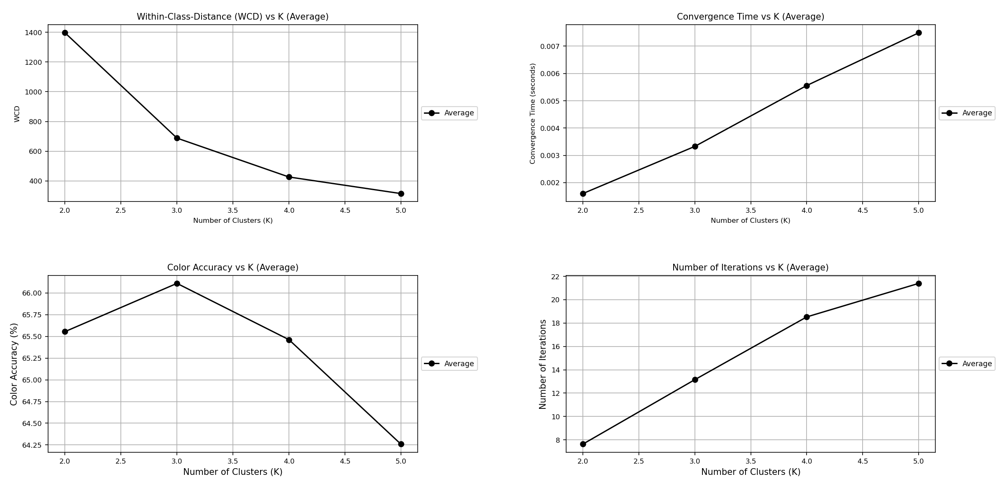

Here it is observed that using the cropped images the accuracy rate, the convergence time and the number of iterations improve considerably compared to the use of the unmodified images.

1. **Random Method:**

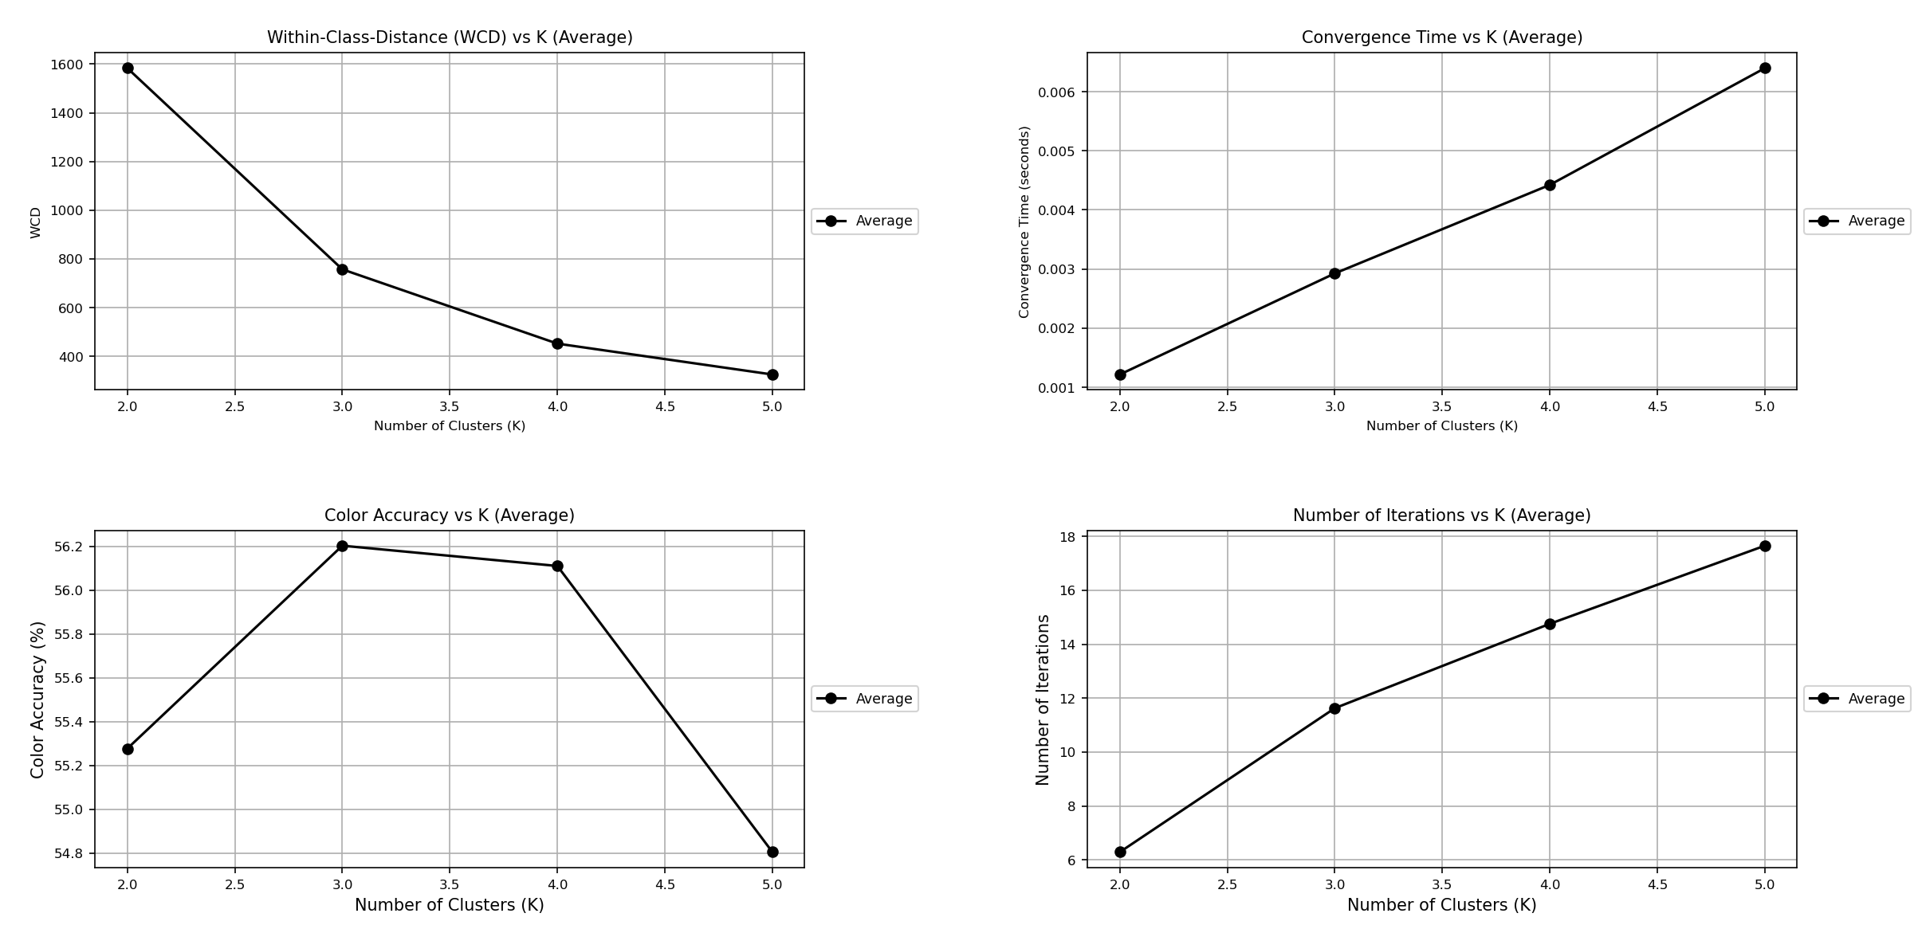

As with the previous method, results are better with cropped images. Compared to the First method, in this case we can see that the convergence time and the number of iterations is slightly better. In color accuracy there is a significant decrease in performance, going from an accuracy range of [64,66] to one of [54,56].

1. **Kmeans++ Method:**

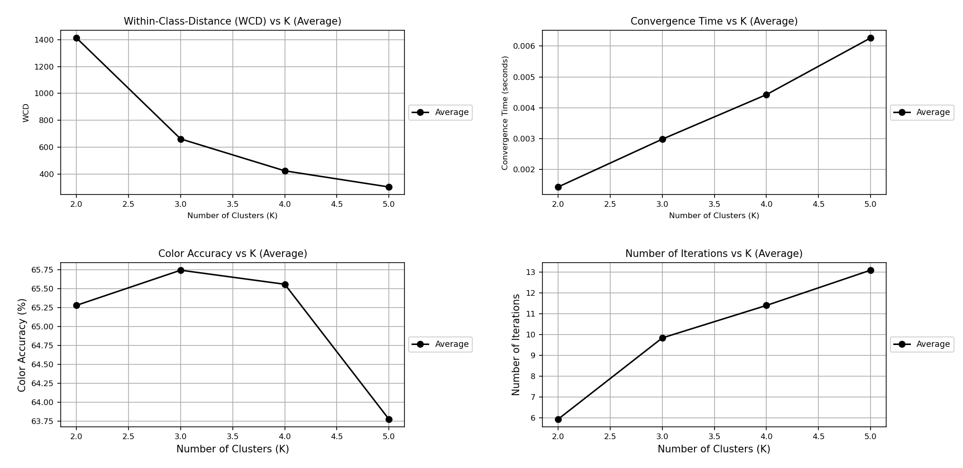

In the case of Kmeans++ with cropped images, a considerable improvement is also seen compared to using unmodified images. But compared to the previous methods using cropped images we can see a very small improvement in the accuracy rate, convergence time and number of iterations, but it is still not significant.

### Test 3

For this test we are going to follow the same philosophy of applying the three initialization methods that we have, but this time we will do it on only a cropped image to see if on a small scale we can detect any changes that are significant. This is going to be the image that we are going to evaluate:

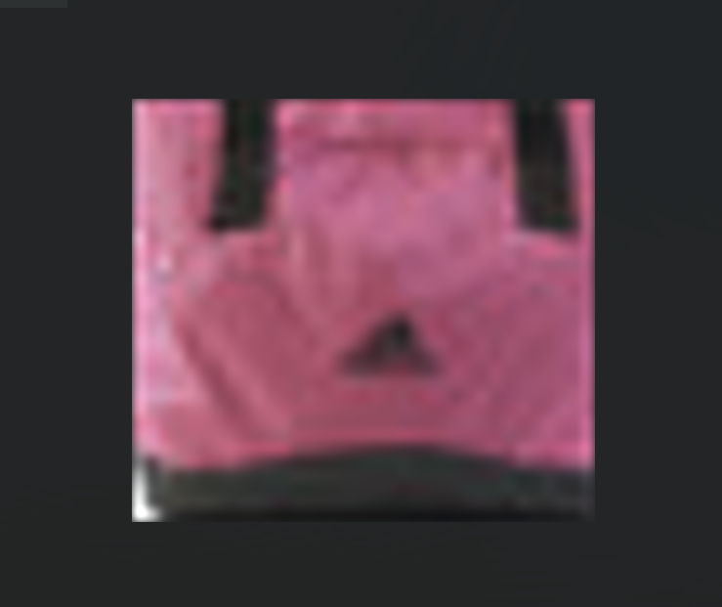

1. **First n points Method:**

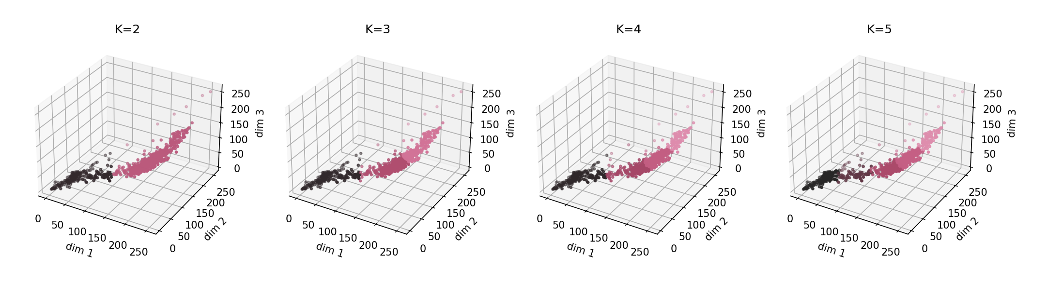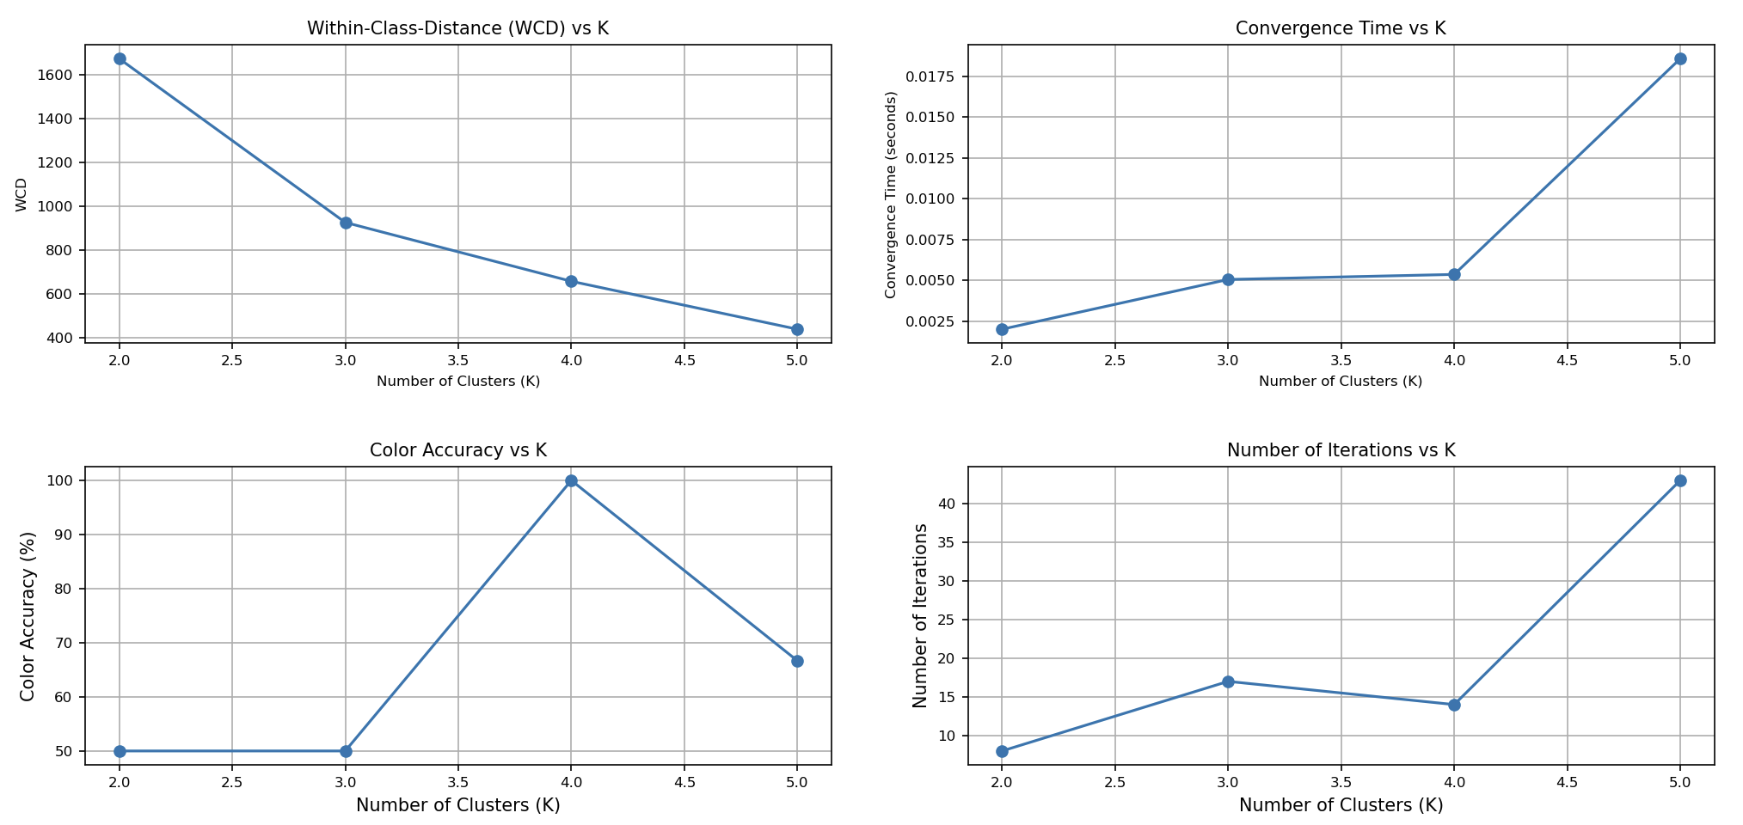

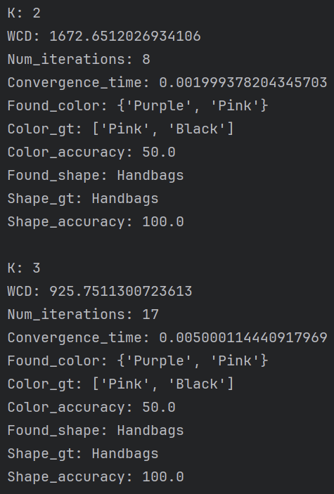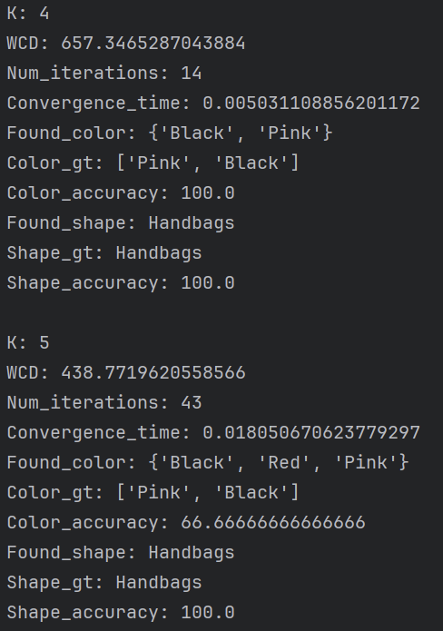

1. **Random Method:**

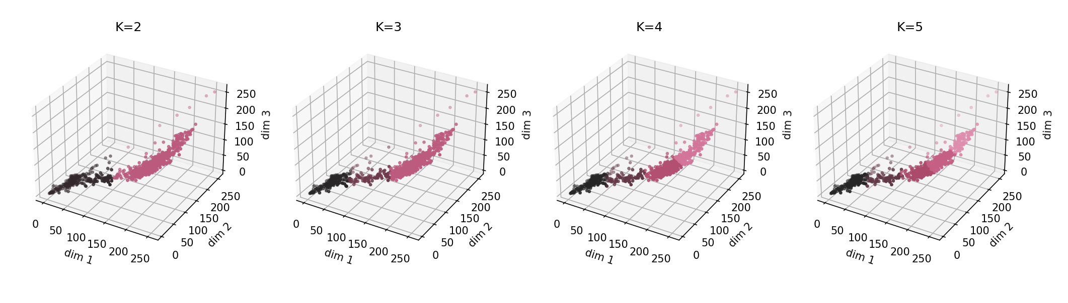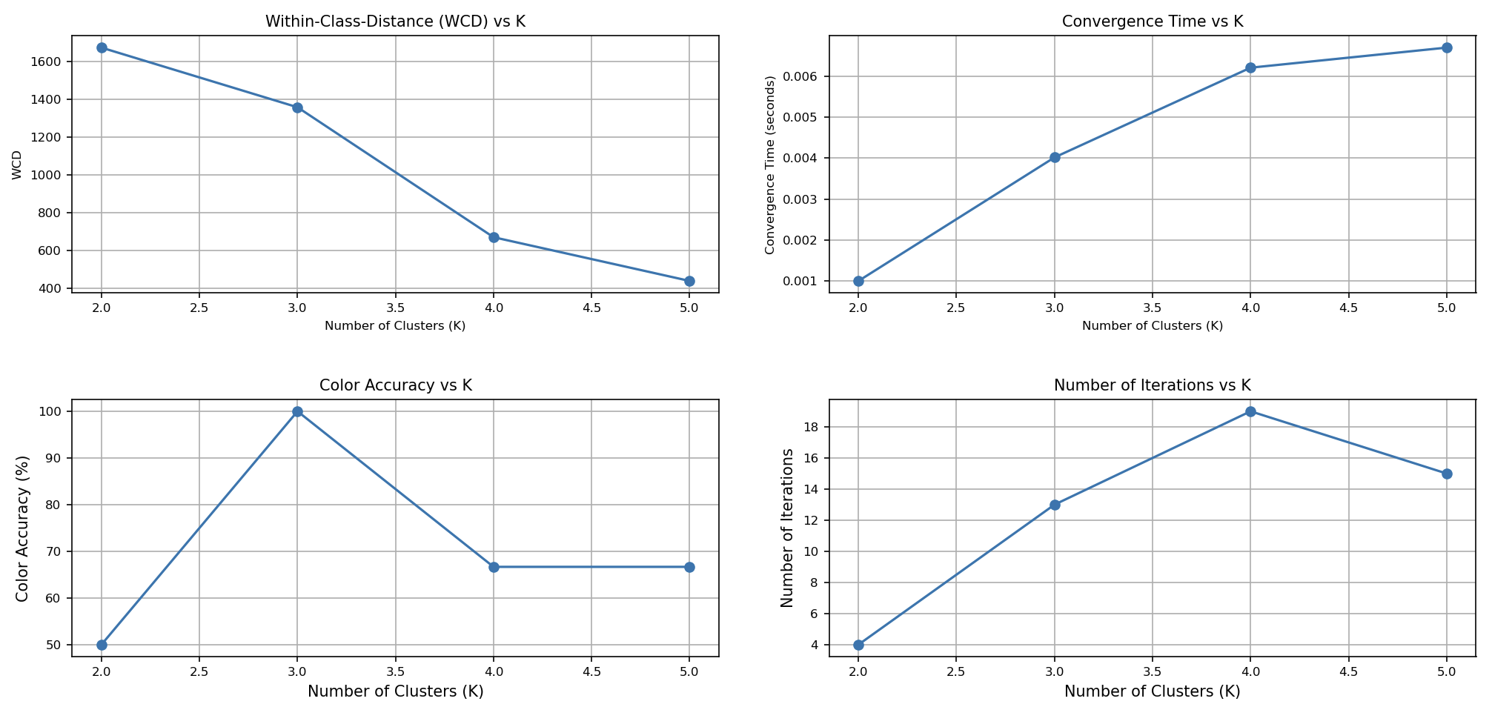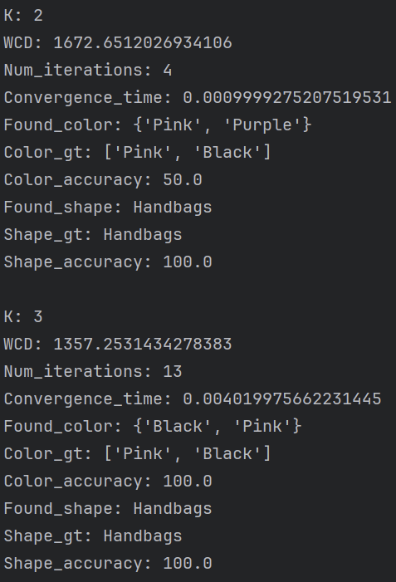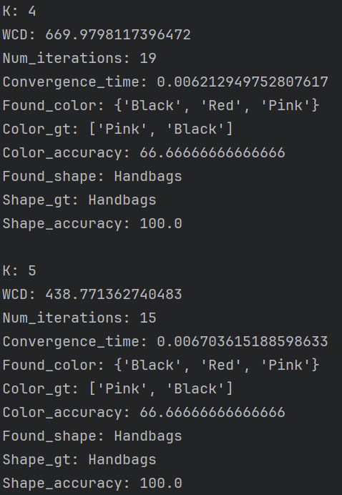

1. **Kmeans++ Method:**

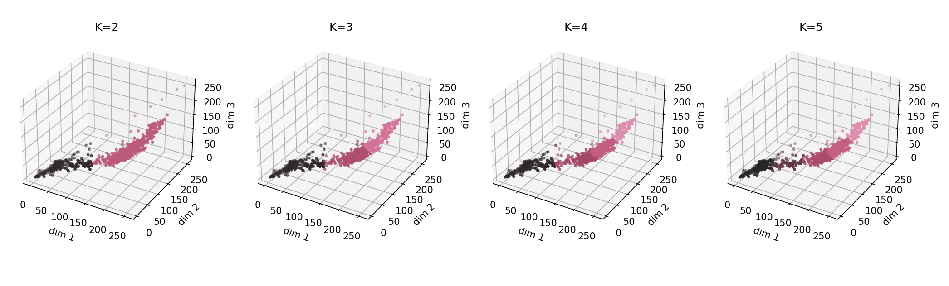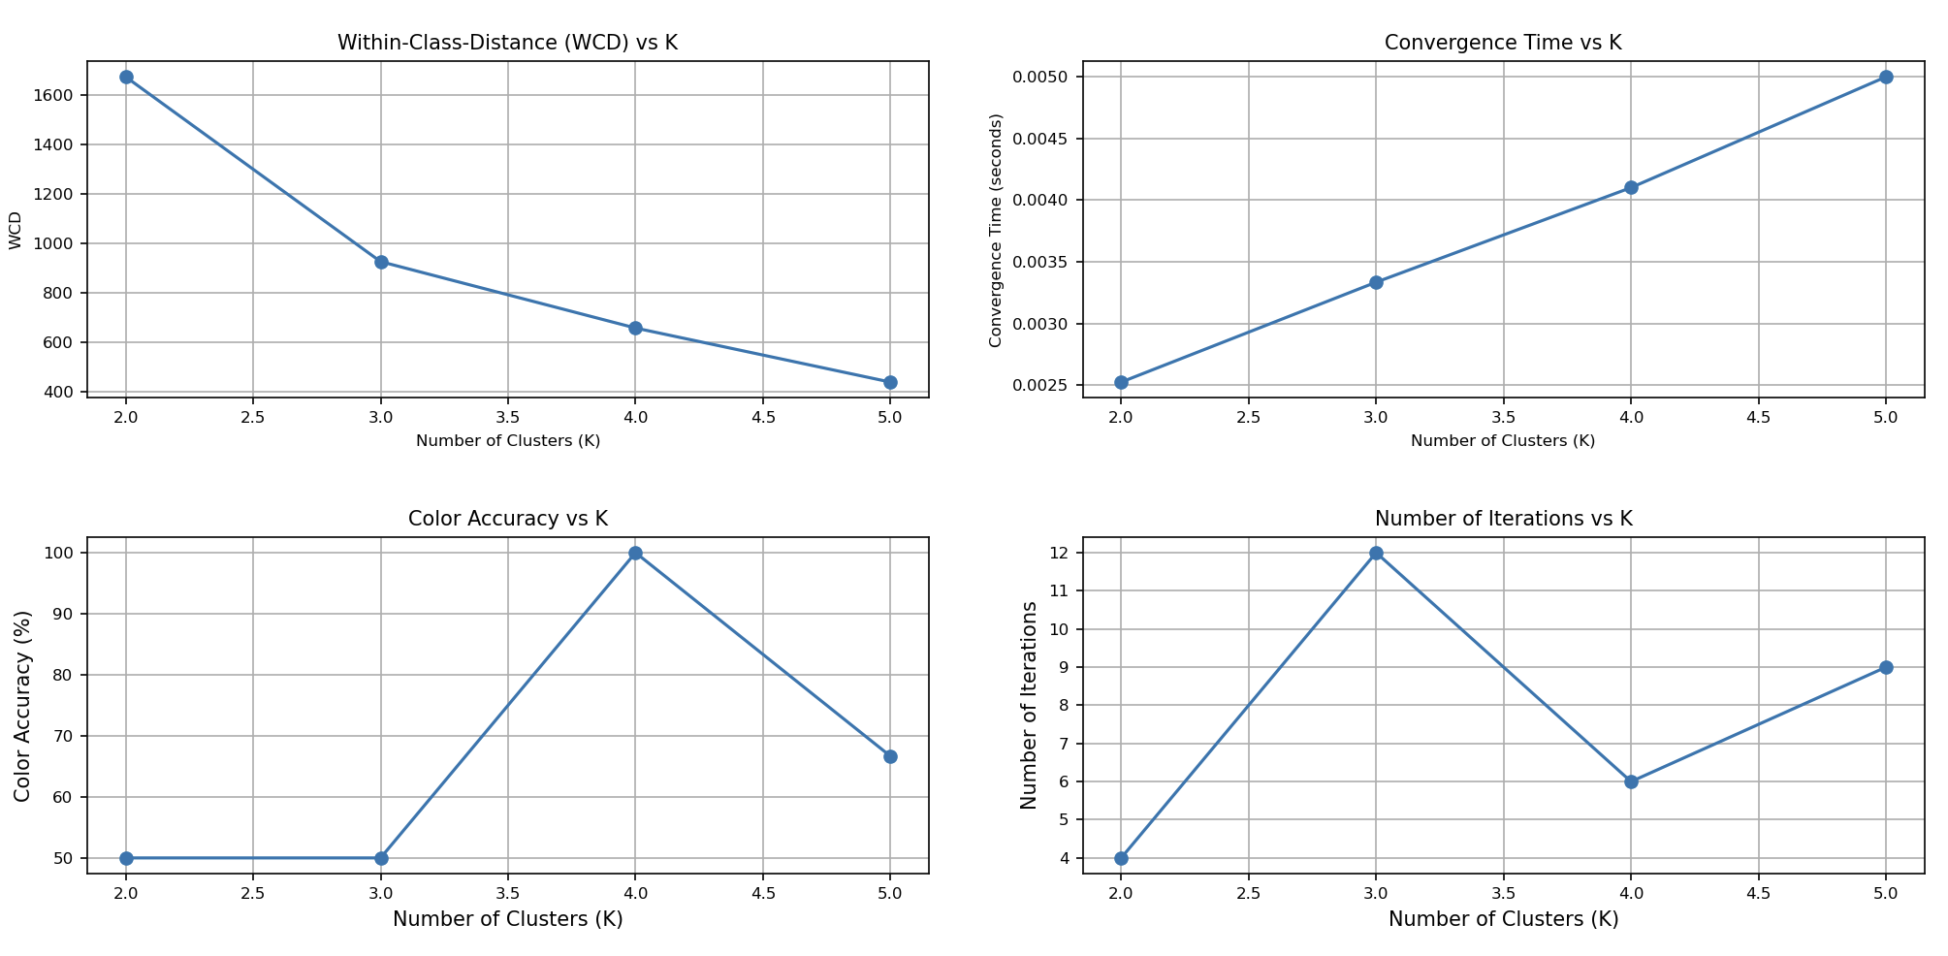

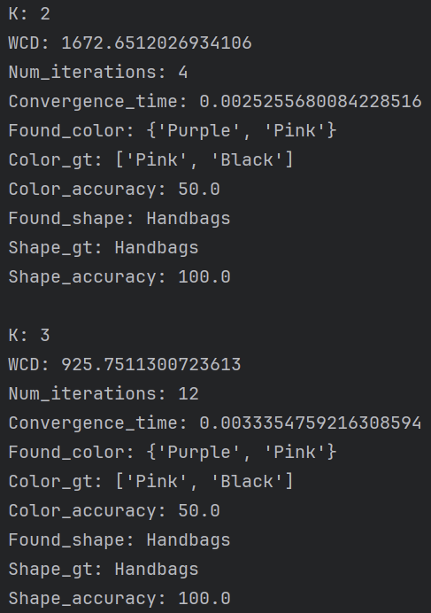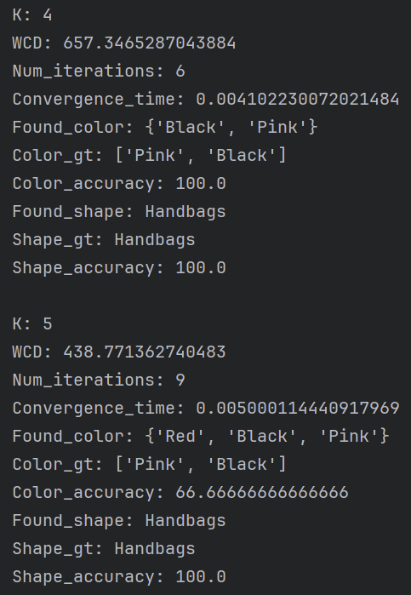

Looking at the results on this image we can conclude that the WCD and the accuracy rate are almost identical in all initialization methods. It is in the other two measures where we see the biggest improvements. For the First method we have 43 iterations at k = 5, with the Random method we have 15 iterations and with the Kmeans++ 9 iterations. The improvement in convergence time increases in the same way, since it depends directly on the number of iterations.

## Conclusion

The Kmeans++ method chooses centroids more intelligently than the other two methods, resulting in much better convergence times and accuracy rates, as we have seen in Test 3. In tests 1 and 2 the average improvements over these measurements is slighter, although if we were to perform the same tests on a much more massive set of images we would see a considerable change.

However, it must be taken into account that a large part of the improvements are due to using cropped images, since by eliminating the background color or eliminating the model and leaving only the garment in the image, K-means can better classify the colors. Even so, it is clear that Kmeans++ is the best initialization option that we can choose for our garment classification problem.

## Fisher Coeficient

The idea is to improve the K-means classification by applying the Fisher coefficient, which uses both the Intra-class and the Inter-class. In order to program we would only have to design the Inter-class, since in the previous installment we already We had designed the Intra-class, and the Fisher coefficient which is equivalent to the following formula that applies the previous two:

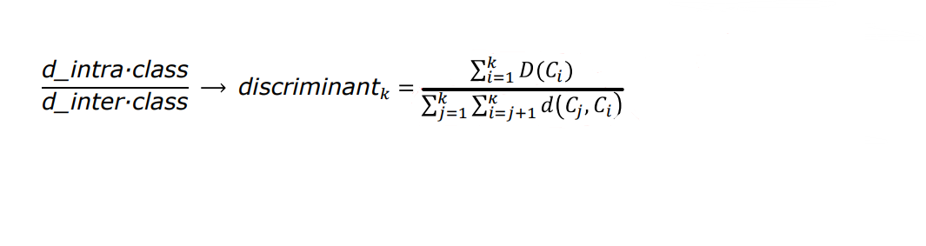

This will improve the classification as it provides a better relationship both inside the class and outside it, hence using both Intra and Inter discriminants.

The objective is for the discriminant to be as small as possible, which would indicate that the distance between different classes is as high as possible, on the other hand, the distance within the same classes is as low as possible, this would indicate a good distribution, such as in the following example, provided from the PDF presented in class.

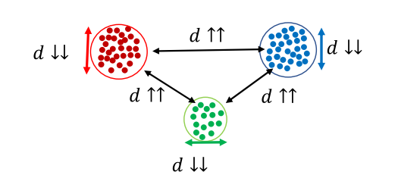

Results for 10 images testing with up to 10 K:

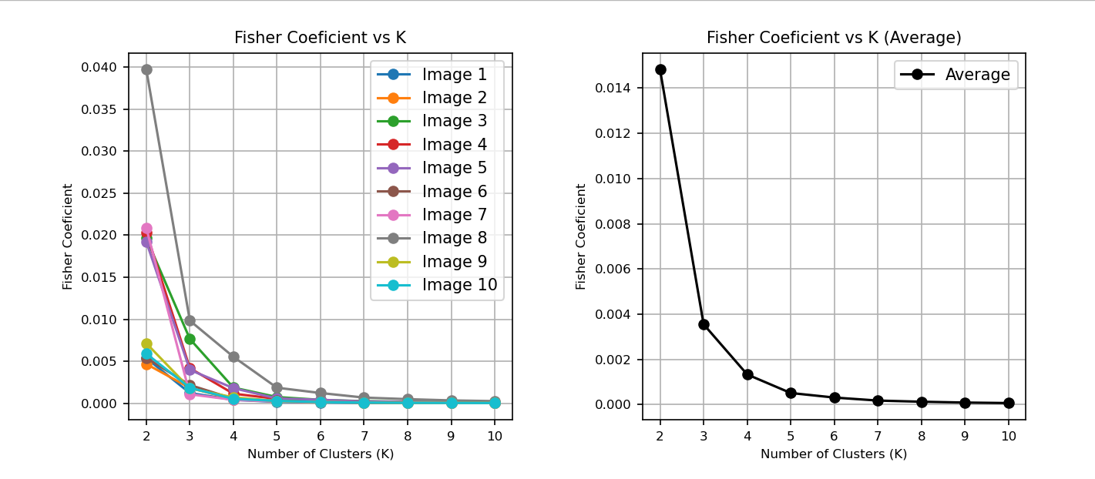This tells us that the more K the Fisher coefficient will be smaller, which indicates a better classification when creating the different classes. This example is based on 10 images, but in the following one that deals with 100 images we can also observe it.

Results for 100 cropped images compared to the average success rate:

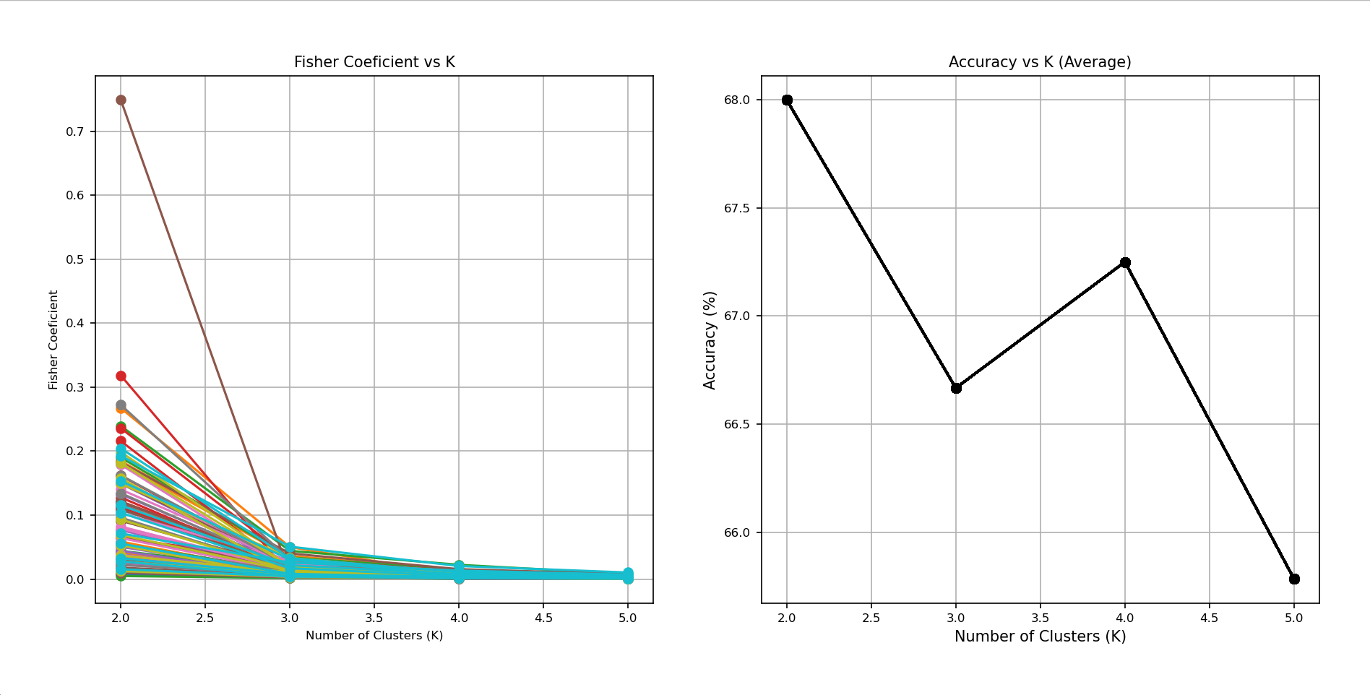

In the previous graphs we observe the relationship between the success with the K and the Fisher coefficient, we can see that although the Fisher coefficient improves, the success is a bit relative, this also depends to a large extent on the ground_truth, that is why we can see peak in K=2 and K=4, most likely if we executed this with up to K=10 or more the success would be worse, but actually the classification of the image would be better, in this case we could consider that an appropriate K would be K=4 .

Visualization of 5 images with their respective k and statistics (these tests are executed on the cropped images, so as not to obtain redundant values such as white color or skin color, etc.):

IMG1:

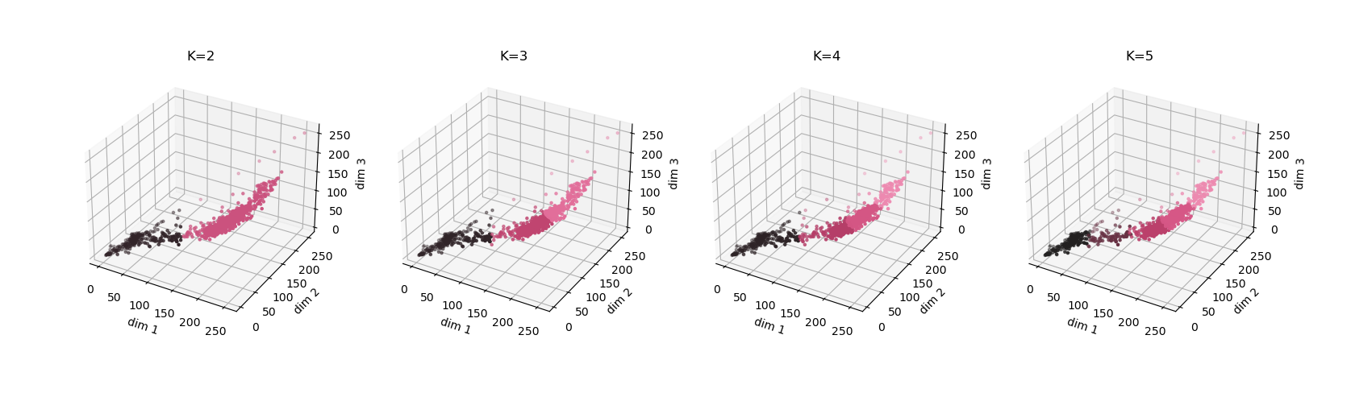

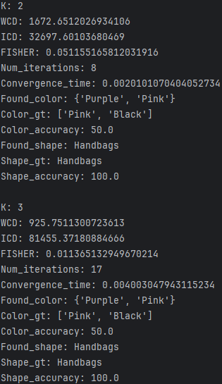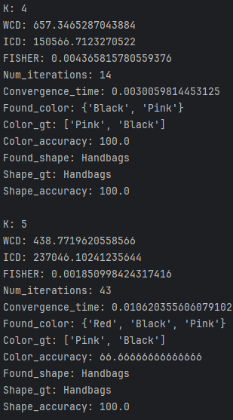

IMG2:

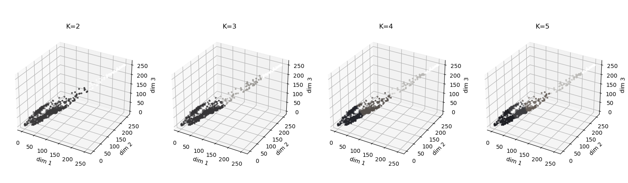

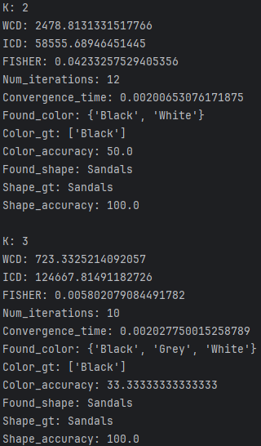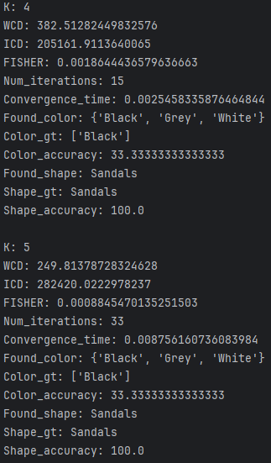

IMG3:

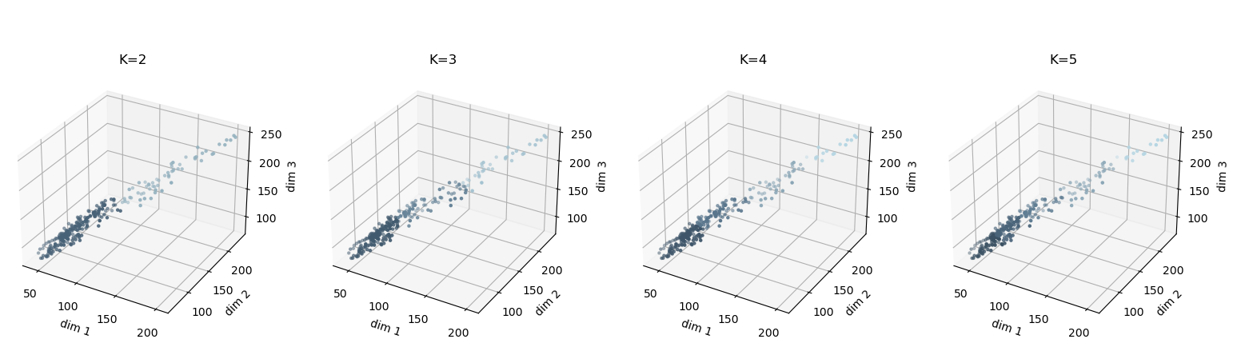

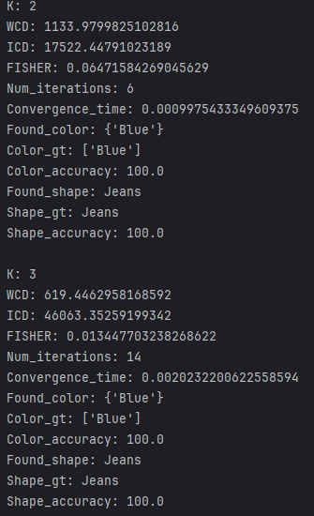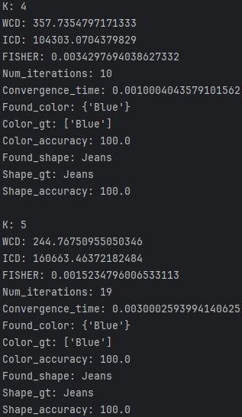

IMG4:

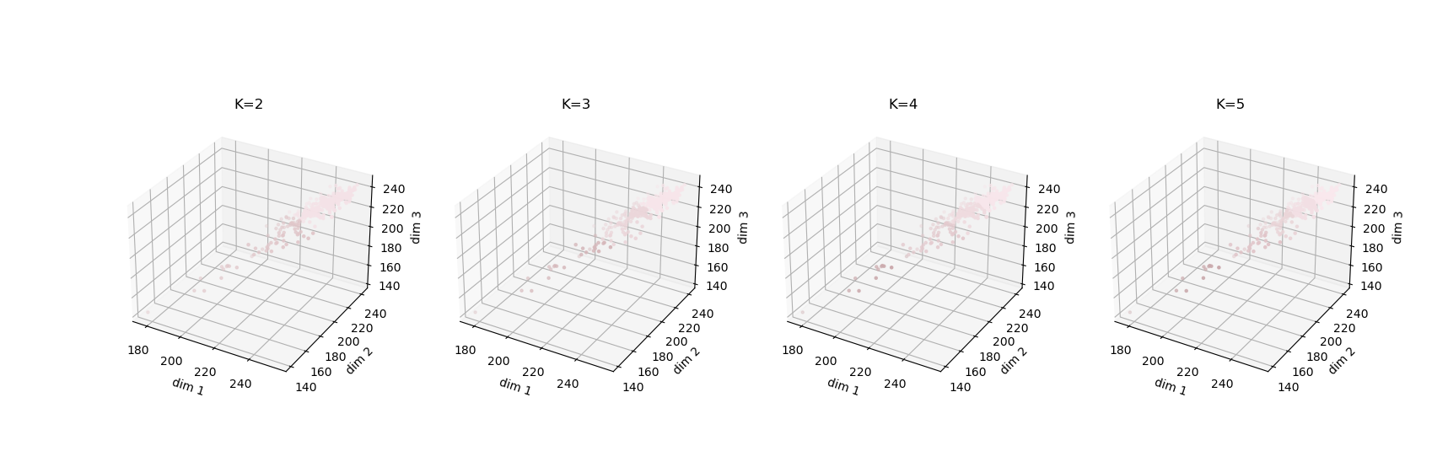

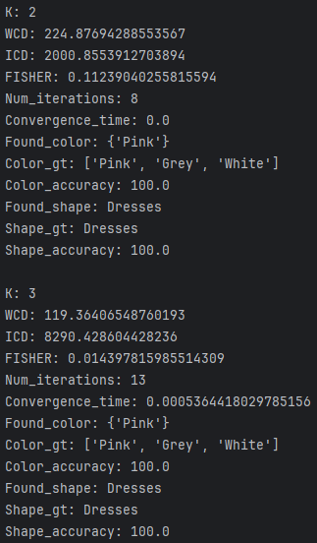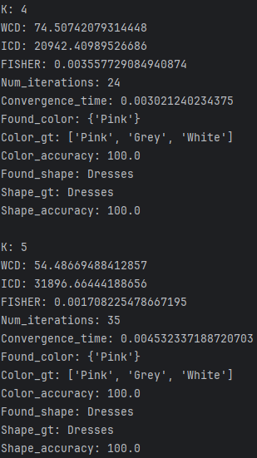

IMG5:

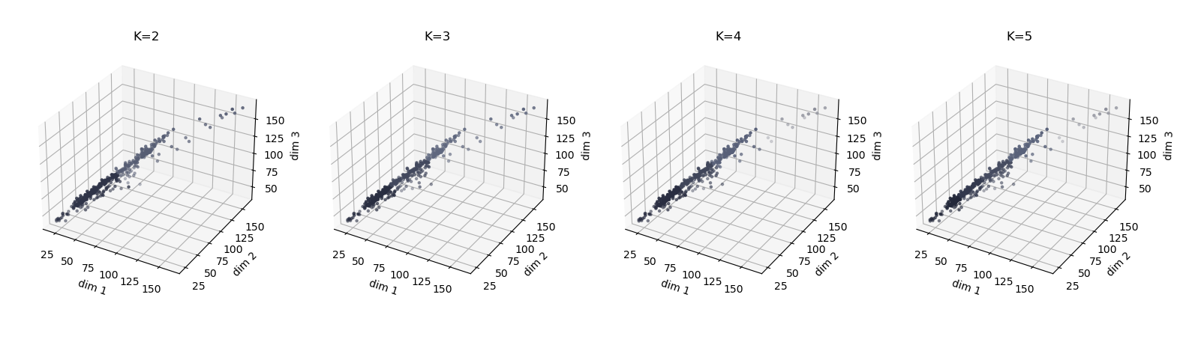

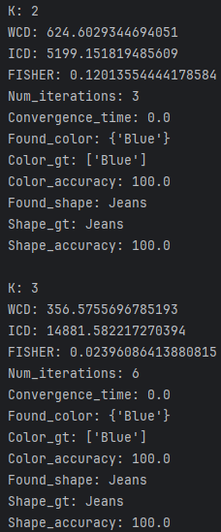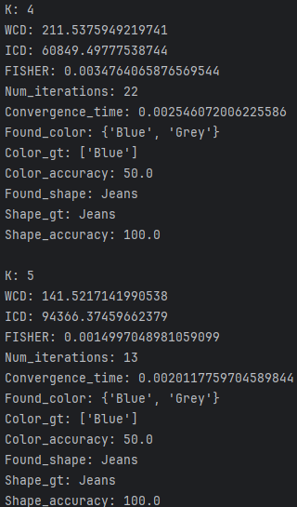

After the previous tests, we see how with the increase of K we improve the Fisher coefficient, we see how the WCD decreases and the ICD increases, this is positive with respect to what we want. If the ground truth were more complex our result would be much better against the better Fisher we have, in this case we would have to look at which K would be more useful to us, we could say that K=4 or K=2 would be very good options in the current scenario.

## Find_BestK:

In the first part of the practice, we used the next formula with a limit of 20% to find the best K:

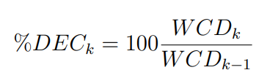

In this improvement we are looking for alternative formulas or trying new thresholds to get a better K.

To do the tests we’ve initially decided to increase and decrease the threshold by 5, in order to have more precision in our decision. As said before we started with an initial threshold of 20, we’ll try to test with 3 uncropped and 3 cropped images. Our max_K will be initially set to 10.

Originally, we thought this would be enough to make good tests but with the 3 images nothing changed so we had to try with a way bigger sample of data.

For starters we made a base of the 3 images and saved the best results with and without the improvements of random / kmeans++ inicialization

***For the “best” results we firstly considered the highest percentage of color accuracy sense that is the purpose of the kmeans and then we looked for the lowest WCD & time.***

Threshold 20% cropped:

|  |  |  |
| --- | --- | --- |
| Img_01 | Img_02 | Img_03 |
| **Normal:**  K: 4  WCD: 657.3465287043884  Num_iterations: 14  Convergence_time: 0.005997419357299805  Found_color: {'Pink', 'Black'}  Color_gt: ['Pink', 'Black']  Color_accuracy: 100.0  Found_shape: Handbags  Shape_gt: Handbags  Shape_accuracy: 100.0  **Con kmeans++:**  K: 4  WCD: 657.3465287043884  Num_iterations: 6  Convergence_time: 0.004000186920166016  Found_color: {'Pink', 'Black'}  Color_gt: ['Pink', 'Black']  Color_accuracy: 100.0  Found_shape: Handbags  Shape_gt: Handbags  Shape_accuracy: 100.0  **Con random:**  K: 3  WCD: 926.1602988679557  Num_iterations: 16  Convergence_time: 0.00599980354309082  Found_color: {'Pink', 'Black'}  Color_gt: ['Pink', 'Black']  Color_accuracy: 100.0  Found_shape: Handbags  Shape_gt: Handbags  Shape_accuracy: 100.0 | **Normal:**  K: 10  WCD: 115.9004695955256  Num_iterations: 25  Convergence_time: 0.03552412986755371  Found_color: {'Grey', 'White', 'Black'}  Color_gt: ['Pink', 'Black']  Color_accuracy: 33.33333333333333  Found_shape: Handbags  Shape_gt: Handbags  Shape_accuracy: 100.0  **Con kmeans++:**  K: 2  WCD: 2479.0276868194464  Num_iterations: 6  Convergence_time: 0.002002239227294922  Found_color: {'White', 'Black'}  Color_gt: ['Pink', 'Black']  Color_accuracy: 50.0  Found_shape: Handbags  Shape_gt: Handbags  Shape_accuracy: 100.0  **Con random:**  K: 2  WCD: 2479.2066301140903  Num_iterations: 10  Convergence_time: 0.003999948501586914  Found_color: {'White', 'Black'}  Color_gt: ['Pink', 'Black']  Color_accuracy: 50.0  Found_shape: Handbags  Shape_gt: Handbags  Shape_accuracy: 100.0 | **Normal:**  K: 9  WCD: 122.56903763401371  Num_iterations: 15  Convergence_time: 0.009000539779663086  Found_color: {'Blue'}  Color_gt: ['Pink', 'Black']  Color_accuracy: 0.0  Found_shape: Handbags  Shape_gt: Handbags  Shape_accuracy: 100.0  **Con kmeans++:**  K: 10  WCD: 86.19469524882537  Num_iterations: 17  Convergence_time: 0.016002655029296875  Found_color: {'Blue'}  Color_gt: ['Pink', 'Black']  Color_accuracy: 0.0  Found_shape: Handbags  Shape_gt: Handbags  Shape_accuracy: 100.0  **Con random:**  K: 8  WCD: 140.10997371445177  Num_iterations: 41  Convergence_time: 0.018003463745117188  Found_color: {'Blue', 'Black'}  Color_gt: ['Pink', 'Black']  Color_accuracy: 50.0  Found_shape: Handbags  Shape_gt: Handbags  Shape_accuracy: 100.0 |

Threshold 20% un-cropped:

|  |  |  |
| --- | --- | --- |
| Img_01 | Img_02 | Img_03 |
| **Normal:**  K: 2  WCD: 678.388323581342  Num_iterations: 3  Convergence_time: 0.003000497817993164  Found_color: {'White', 'Black'}  Color_gt: ['Pink', 'Black']  Color_accuracy: 50.0  Found_shape: Handbags  Shape_gt: Handbags  Shape_accuracy: 100.0  **Con kmeans++:**  K: 2  WCD: 678.388323581342  Num_iterations: 3  Convergence_time: 0.003000497817993164  Found_color: {'White', 'Black'}  Color_gt: ['Pink', 'Black']  Color_accuracy: 50.0  Found_shape: Handbags  Shape_gt: Handbags  Shape_accuracy: 100.0  **Con random:**  K: 2  WCD: 678.388323581342  Num_iterations: 5  Convergence_time: 0.0037398338317871094  Found_color: {'White', 'Black'}  Color_gt: ['Pink', 'Black']  Color_accuracy: 50.0  Found_shape: Handbags  Shape_gt: Handbags  Shape_accuracy: 100.0 | **Normal:**  K: 2  WCD: 545.0106497914171  Num_iterations: 4  Convergence_time: 0.009015083312988281  Found_color: {'White', 'Black'}  Color_gt: ['Pink', 'Black']  Color_accuracy: 50.0  Found_shape: Handbags  Shape_gt: Handbags  Shape_accuracy: 100.0  **Con Kmeans++:**  K: 2  WCD: 545.0106497914171  Num_iterations: 3  Convergence_time: 0.0040018558502197266  Found_color: {'White', 'Black'}  Color_gt: ['Pink', 'Black']  Color_accuracy: 50.0  Found_shape: Handbags  Shape_gt: Handbags  Shape_accuracy: 100.0  **Con random:**  K: 2  WCD: 545.0106497914171  Num_iterations: 4  Convergence_time: 0.003995656967163086  Found_color: {'White', 'Black'}  Color_gt: ['Pink', 'Black']  Color_accuracy: 50.0  Found_shape: Handbags  Shape_gt: Handbags  Shape_accuracy: 100.0 | **Normal:**  K: 4  WCD: 609.4479810053048  Num_iterations: 25  Convergence_time: 0.0480191707611084  Found_color: {'Red', 'Orange', 'White', 'Black'}  Color_gt: ['Pink', 'Black']  Color_accuracy: 25.0  Found_shape: Handbags  Shape_gt: Handbags  Shape_accuracy: 100.0  **Con Kmeans++:**  K: 4  WCD: 609.4479810053048  Num_iterations: 7  Convergence_time: 0.013017416000366211  Found_color: {'Orange', 'Red', 'White', 'Black'}  Color_gt: ['Pink', 'Black']  Color_accuracy: 25.0  Found_shape: Handbags  Shape_gt: Handbags  Shape_accuracy: 100.0  **Con Random:**  K: 3  WCD: 1154.8341365204988  Num_iterations: 12  Convergence_time: 0.015085697174072266  Found_color: {'Red', 'White', 'Black'}  Color_gt: ['Pink', 'Black']  Color_accuracy: 33.33333333333333  Found_shape: Handbags  Shape_gt: Handbags  Shape_accuracy: 100.0 |

At this point we were making lots of tests and to not overcomplicate the results we decided that the most efficient way is not to do 10 executions of the kmeans per each option for each image (30 executions per image, each of this could take 4 –60 iterations). So we will continue without executing the other improvements.

Test 1

Threshold 15% cropped:

|  |  |  |
| --- | --- | --- |
| Img1 | Img2 | Img3 |
| K: 4  WCD: 657.3465287043884  Num_iterations: 14  Convergence_time: 0.004997730255126953  Found_color: {'Pink', 'Black'}  Color_gt: ['Pink', 'Black']  Color_accuracy: 100.0  Found_shape: Handbags  Shape_gt: Handbags  Shape_accuracy: 100.0 | K: 2  WCD: 2479.2066301140903  Num_iterations: 9  Convergence_time: 0.003998279571533203  Found_color: {'White', 'Black'}  Color_gt: ['Pink', 'Black']  Color_accuracy: 50.0  Found_shape: Handbags  Shape_gt: Handbags  Shape_accuracy: 100.0 | K: 10  WCD: 117.52717960233952  Num_iterations: 15  Convergence_time: 0.008000373840332031  Found_color: {'Blue'}  Color_gt: ['Pink', 'Black']  Color_accuracy: 0.0  Found_shape: Handbags  Shape_gt: Handbags  Shape_accuracy: 100.0 |

Threshold 15% un-cropped:

|  |  |  |
| --- | --- | --- |
| Img1 | Img2 | Img3 |
| K: 2  WCD: 678.388323581342  Num_iterations: 5  Convergence_time: 0.013007402420043945  Found_color: {'White', 'Black'}  Color_gt: ['Pink', 'Black']  Color_accuracy: 50.0  Found_shape: Handbags  Shape_gt: Handbags  Shape_accuracy: 100.0 | K: 2  WCD: 545.0106497914171  Num_iterations: 4  Convergence_time: 0.009999513626098633  Found_color: {'White', 'Black'}  Color_gt: ['Pink', 'Black']  Color_accuracy: 50.0  Found_shape: Handbags  Shape_gt: Handbags  Shape_accuracy: 100.0 | K: 4  WCD: 609.4479810053048  Num_iterations: 25  Convergence_time: 0.02802133560180664  Found_color: {'Red', 'Orange', 'White', 'Black'}  Color_gt: ['Pink', 'Black']  Color_accuracy: 25.0  Found_shape: Handbags  Shape_gt: Handbags  Shape_accuracy: 100.0 |

### Test 2

Threshold 10% cropped:

|  |  |  |
| --- | --- | --- |
| Img1 | Img2 | Img3 |
| K: 4  WCD: 657.3465287043884  Num_iterations: 14  Convergence_time: 0.009003400802612305  Found_color: {'Pink', 'Black'}  Color_gt: ['Pink', 'Black']  Color_accuracy: 100.0  Found_shape: Handbags  Shape_gt: Handbags  Shape_accuracy: 100.0 | K: 2  WCD: 2479.2066301140903  Num_iterations: 9  Convergence_time: 0.002996683120727539  Found_color: {'White', 'Black'}  Color_gt: ['Pink', 'Black']  Color_accuracy: 50.0  Found_shape: Handbags  Shape_gt: Handbags  Shape_accuracy: 100.0 | K: 10  WCD: 117.52717960233952  Num_iterations: 15  Convergence_time: 0.008049249649047852  Found_color: {'Blue'}  Color_gt: ['Pink', 'Black']  Color_accuracy: 0.0  Found_shape: Handbags  Shape_gt: Handbags  Shape_accuracy: 100.0 |

Threshold 10% un-cropped:

|  |  |  |
| --- | --- | --- |
| Img1 | Img2 | Img3 |
| K: 2  WCD: 678.388323581342  Num_iterations: 5  Convergence_time: 0.008966207504272461  Found_color: {'White', 'Black'}  Color_gt: ['Pink', 'Black']  Color_accuracy: 50.0  Found_shape: Handbags  Shape_gt: Handbags  Shape_accuracy: 100.0 | K: 2  WCD: 545.0106497914171  Num_iterations: 4  Convergence_time: 0.008865833282470703  Found_color: {'White', 'Black'}  Color_gt: ['Pink', 'Black']  Color_accuracy: 50.0  Found_shape: Handbags  Shape_gt: Handbags  Shape_accuracy: 100.0 | K: 4  WCD: 609.4479810053048  Num_iterations: 25  Convergence_time: 0.03654313087463379  Found_color: {'Red', 'Orange', 'White', 'Black'}  Color_gt: ['Pink', 'Black']  Color_accuracy: 25.0  Found_shape: Handbags  Shape_gt: Handbags  Shape_accuracy: 100.0 |

### Test 3

Threshold 25% cropped:

|  |  |  |
| --- | --- | --- |
| Img1 | Img2 | Img3 |
| K: 4  WCD: 657.3465287043884  Num_iterations: 14  Convergence_time: 0.009999513626098633  Found_color: {'Pink', 'Black'}  Color_gt: ['Pink', 'Black']  Color_accuracy: 100.0  Found_shape: Handbags  Shape_gt: Handbags  Shape_accuracy: 100.0 | K: 2  WCD: 2479.2066301140903  Num_iterations: 9  Convergence_time: 0.0030002593994140625  Found_color: {'White', 'Black'}  Color_gt: ['Pink', 'Black']  Color_accuracy: 50.0  Found_shape: Handbags  Shape_gt: Handbags  Shape_accuracy: 100.0 | K: 10  WCD: 117.52717960233952  Num_iterations: 15  Convergence_time: 0.013999223709106445  Found_color: {'Blue'}  Color_gt: ['Pink', 'Black']  Color_accuracy: 0.0  Found_shape: Handbags  Shape_gt: Handbags  Shape_accuracy: 100.0 |

Threshold 25% un-cropped:

|  |  |  |
| --- | --- | --- |
| Img1 | Img2 | Img3 |
| K: 2  WCD: 678.388323581342  Num_iterations: 5  Convergence_time: 0.009000301361083984  Found_color: {'White', 'Black'}  Color_gt: ['Pink', 'Black']  Color_accuracy: 50.0  Found_shape: Handbags  Shape_gt: Handbags  Shape_accuracy: 100.0 | K: 2  WCD: 545.0106497914171  Num_iterations: 4  Convergence_time: 0.00899505615234375  Found_color: {'White', 'Black'}  Color_gt: ['Pink', 'Black']  Color_accuracy: 50.0  Found_shape: Handbags  Shape_gt: Handbags  Shape_accuracy: 100.0 | K: 4  WCD: 609.4479810053048  Num_iterations: 25  Convergence_time: 0.027010679244995117  Found_color: {'Red', 'Orange', 'White', 'Black'}  Color_gt: ['Pink', 'Black']  Color_accuracy: 25.0  Found_shape: Handbags  Shape_gt: Handbags  Shape_accuracy: 100.0 |

### Test 4

Threshold 30% cropped:

|  |  |  |
| --- | --- | --- |
| Img1 | Img2 | Img3 |
| K: 4  WCD: 657.3465287043884  Num_iterations: 14  Convergence_time: 0.00699615478515625  Found_color: {'Pink', 'Black'}  Color_gt: ['Pink', 'Black']  Color_accuracy: 100.0  Found_shape: Handbags  Shape_gt: Handbags  Shape_accuracy: 100.0 | K: 2  WCD: 2479.2066301140903  Num_iterations: 9  Convergence_time: 0.004004001617431641  Found_color: {'White', 'Black'}  Color_gt: ['Pink', 'Black']  Color_accuracy: 50.0  Found_shape: Handbags  Shape_gt: Handbags  Shape_accuracy: 100.0 | K: 10  WCD: 117.52717960233952  Num_iterations: 15  Convergence_time: 0.007998943328857422  Found_color: {'Blue'}  Color_gt: ['Pink', 'Black']  Color_accuracy: 0.0  Found_shape: Handbags  Shape_gt: Handbags  Shape_accuracy: 100.0 |

Threshold 30% un-cropped:

|  |  |  |
| --- | --- | --- |
| Img1 | Img2 | Img3 |
| K: 2  WCD: 678.388323581342  Num_iterations: 5  Convergence_time: 0.025196313858032227  Found_color: {'White', 'Black'}  Color_gt: ['Pink', 'Black']  Color_accuracy: 50.0  Found_shape: Handbags  Shape_gt: Handbags  Shape_accuracy: 100.0 | K: 2  WCD: 545.0106497914171  Num_iterations: 4  Convergence_time: 0.008005142211914062  Found_color: {'White', 'Black'}  Color_gt: ['Pink', 'Black']  Color_accuracy: 50.0  Found_shape: Handbags  Shape_gt: Handbags  Shape_accuracy: 100.0 | K: 4  WCD: 609.4479810053048  Num_iterations: 25  Convergence_time: 0.026999473571777344  Found_color: {'Red', 'Orange', 'White', 'Black'}  Color_gt: ['Pink', 'Black']  Color_accuracy: 25.0  Found_shape: Handbags  Shape_gt: Handbags  Shape_accuracy: 100.0 |

### Test 5

For the 5th test we decided to do the previous test but only with cropped images and a greater number of images (10)

Threshold 20:

|  |  |  |  |  |
| --- | --- | --- | --- | --- |
| Img1 | Img2 | Img3 | Img4 | Img5 |
| K: 4  WCD: 657.3465287043884  Num_iterations: 14  Convergence_time: 0.007711172103881836  Found_color: {'Pink', 'Black'}  Color_gt: ['Pink', 'Black']  Color_accuracy: 100.0  Found_shape: Handbags  Shape_gt: Handbags  Shape_accuracy: 100.0 | K: 2  WCD: 2479.2066301140903  Num_iterations: 9  Convergence_time: 0.0029964447021484375  Found_color: {'White', 'Black'}  Color_gt: ['Pink', 'Black']  Color_accuracy: 50.0  Found_shape: Handbags  Shape_gt: Handbags  Shape_accuracy: 100.0 | K: 10  WCD: 117.52717960233952  Num_iterations: 15  Convergence_time: 0.007977962493896484  Found_color: {'Blue'}  Color_gt: ['Pink', 'Black']  Color_accuracy: 0.0  Found_shape: Handbags  Shape_gt: Handbags  Shape_accuracy: 100.0 | K: 2  WCD: 224.87694288553567  Num_iterations: 8  Convergence_time: 0.0019996166229248047  Found_color: {'Pink'}  Color_gt: ['Pink', 'Black']  Color_accuracy: 100.0  Found_shape: Handbags  Shape_gt: Handbags  Shape_accuracy: 100.0 | K: 10  WCD: 46.92199955837047  Num_iterations: 22  Convergence_time: 0.01502084732055664  Found_color: {'Grey', 'Blue'}  Color_gt: ['Pink', 'Black']  Color_accuracy: 0.0  Found_shape: Handbags  Shape_gt: Handbags  Shape_accuracy: 100.0 |
| Img6 | Img7 | Img8 | Img9 | Img10 |
| K: 7  WCD: 228.7659958831942  Num_iterations: 48  Convergence_time: 0.0379643440246582  Found_color: {'Grey', 'White', 'Orange', 'Black'}  Color_gt: ['Pink', 'Black']  Color_accuracy: 25.0  Found_shape: Handbags  Shape_gt: Handbags  Shape_accuracy: 100.0 | K: 6  WCD: 256.100895673273  Num_iterations: 22  Convergence_time: 0.01125192642211914  Found_color: {'Pink'}  Color_gt: ['Pink', 'Black']  Color_accuracy: 100.0  Found_shape: Handbags  Shape_gt: Handbags  Shape_accuracy: 100.0 | K: 2  WCD: 245.23956868706057  Num_iterations: 4  Convergence_time: 0.000997304916381836  Found_color: {'Grey', 'Black'}  Color_gt: ['Pink', 'Black']  Color_accuracy: 50.0  Found_shape: Handbags  Shape_gt: Handbags  Shape_accuracy: 100.0 | K: 2  WCD: 25.59950827721661  Num_iterations: 7  Convergence_time: 0.0020067691802978516  Found_color: {'Black'}  Color_gt: ['Pink', 'Black']  Color_accuracy: 100.0  Found_shape: Handbags  Shape_gt: Handbags  Shape_accuracy: 100.0 | K: 8  WCD: 164.48339336004668  Num_iterations: 22  Convergence_time: 0.01703500747680664  Found_color: {'Pink', 'Red', 'Blue', 'Grey'}  Color_gt: ['Pink', 'Black']  Color_accuracy: 25.0  Found_shape: Handbags  Shape_gt: Handbags  Shape_accuracy: 100.0 |

Treashold 10:

|  |  |  |  |  |
| --- | --- | --- | --- | --- |
| Img1 | Img2 | Img3 | Img4 | Img5 |
| K: 4  WCD: 657.3465287043884  Num_iterations: 14  Convergence_time: 0.007711172103881836  Found_color: {'Pink', 'Black'}  Color_gt: ['Pink', 'Black']  Color_accuracy: 100.0  Found_shape: Handbags  Shape_gt: Handbags  Shape_accuracy: 100.0 | K: 2  WCD: 2479.2066301140903  Num_iterations: 9  Convergence_time: 0.0029964447021484375  Found_color: {'White', 'Black'}  Color_gt: ['Pink', 'Black']  Color_accuracy: 50.0  Found_shape: Handbags  Shape_gt: Handbags  Shape_accuracy: 100.0 | K: 10  WCD: 117.52717960233952  Num_iterations: 15  Convergence_time: 0.007977962493896484  Found_color: {'Blue'}  Color_gt: ['Pink', 'Black']  Color_accuracy: 0.0  Found_shape: Handbags  Shape_gt: Handbags  Shape_accuracy: 100.0 | K: 2  WCD: 224.87694288553567  Num_iterations: 8  Convergence_time: 0.0019996166229248047  Found_color: {'Pink'}  Color_gt: ['Pink', 'Black']  Color_accuracy: 100.0  Found_shape: Handbags  Shape_gt: Handbags  Shape_accuracy: 100.0 | K: 10  WCD: 46.92199955837047  Num_iterations: 22  Convergence_time: 0.01502084732055664  Found_color: {'Grey', 'Blue'}  Color_gt: ['Pink', 'Black']  Color_accuracy: 0.0  Found_shape: Handbags  Shape_gt: Handbags  Shape_accuracy: 100.0 |
| Img6 | Img7 | Img8 | Img9 | Img10 |
| K: 7  WCD: 228.7659958831942  Num_iterations: 48  Convergence_time: 0.0379643440246582  Found_color: {'Grey', 'White', 'Orange', 'Black'}  Color_gt: ['Pink', 'Black']  Color_accuracy: 25.0  Found_shape: Handbags  Shape_gt: Handbags  Shape_accuracy: 100.0 | K: 6  WCD: 256.100895673273  Num_iterations: 22  Convergence_time: 0.01125192642211914  Found_color: {'Pink'}  Color_gt: ['Pink', 'Black']  Color_accuracy: 100.0  Found_shape: Handbags  Shape_gt: Handbags  Shape_accuracy: 100.0 | K: 2  WCD: 245.23956868706057  Num_iterations: 4  Convergence_time: 0.000997304916381836  Found_color: {'Grey', 'Black'}  Color_gt: ['Pink', 'Black']  Color_accuracy: 50.0  Found_shape: Handbags  Shape_gt: Handbags  Shape_accuracy: 100.0 | K: 2  WCD: 25.59950827721661  Num_iterations: 7  Convergence_time: 0.0020067691802978516  Found_color: {'Black'}  Color_gt: ['Pink', 'Black']  Color_accuracy: 100.0  Found_shape: Handbags  Shape_gt: Handbags  Shape_accuracy: 100.0 | K: 8  WCD: 164.48339336004668  Num_iterations: 22  Convergence_time: 0.01703500747680664  Found_color: {'Pink', 'Red', 'Blue', 'Grey'}  Color_gt: ['Pink', 'Black']  Color_accuracy: 25.0  Found_shape: Handbags  Shape_gt: Handbags  Shape_accuracy: 100.0 |

### Test 6

Finally for the last test we decided to test with 100 images and then 1000 without cropping and we observed the accuracy statistics.

Threashold 20 / 15 / 10 / 25 / 30:

MaxK = 10

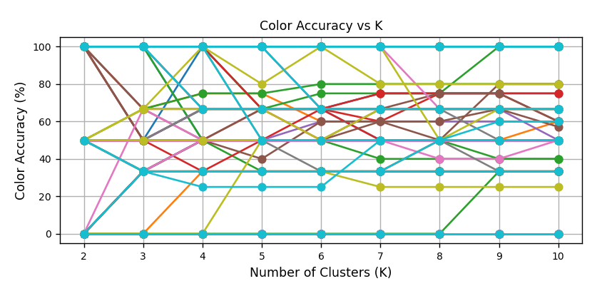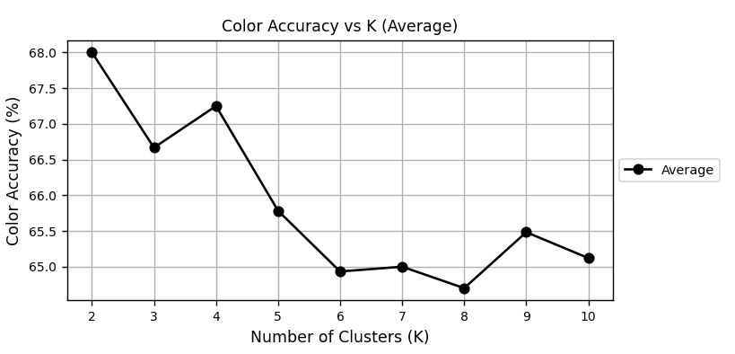

MaxK = 5

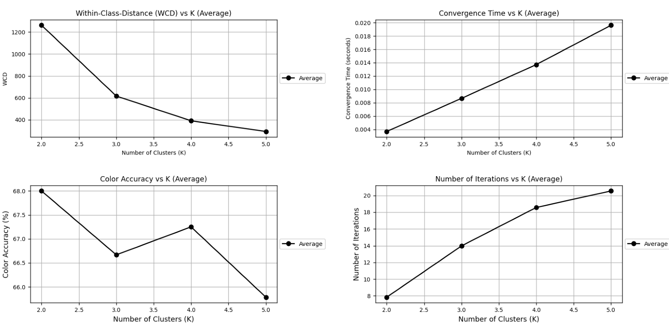

Con 1000 images:

MaxK =10

The values of the results stay the same accuracy at 100 images.

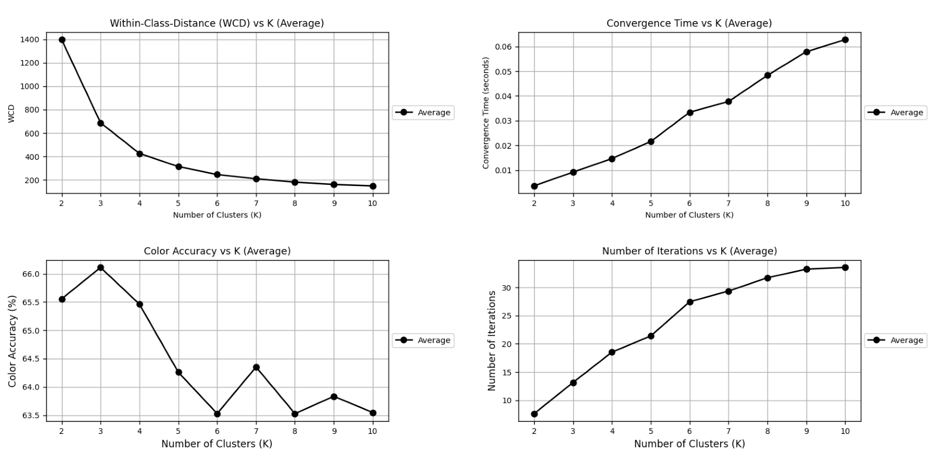

MaxK = 5



### Conclusiones Find_best_K

The conclusion that we took from this improvement was really mixed, a big part of this improvement I was confused and thought there was a mistake or error in the code, but I double checked if thigs were being executed, sense there were no visible substantial improvements in color accuracy and functionality of kmeans. There was a certain improvement in execution with the options that give us more randomness, but other than that no big changes were recorded. In most of the cases the statistics/results repeated themselves for the 5 values of the threshold.

We could also appreciate that after K > 4, there is no real improvement and is not worth it to execute it above that value, sense it’s not beneficial for the program. Also, in some cases it might give more colors than that exist in the image, which is uncommon for the prediction, but it might happen.

The other observations we have are that, gradually increasing K we get a much better WCD, but that doesn't really corelate to better results overall, and most of the time is unnecessary sense having a K = 10 might give us slower times and more accuracy failures.

# Global Conclusions

In conclusion, in this practice we have tried to solve a problem of automated labeling of clothing images using K-Means and KNN algorithms. K-Means has been used to find the main colors of the images and KNN has been used to determine the type of garment.

For the qualitative functions we have implemented all the functions that have been suggested to us, these being retrieve_by_color, retrieve_by_shape and retrieve_combined. We have carried out several tests to verify the correct functioning of the functions. In these tests we have seen that the K-Means algorithm was the one that needed the most improvements, since in cases where the image had a background or the model was present, it failed greatly in predicting the colors of the garments.

For the quantitative functions we have developed functions to study the percentage of success for the K-Means and KNN predictions. In addition, we have implemented several versions of k_means_statistics to be able to evaluate the K-Means and the KNN with different values for k and to be able to process various images. We have also developed several auxiliary functions that we have used in k_means_statistics to create graphs that represent the different measures that we have calculated by running the algorithms several iterations.

Regarding the improvements for K-Means, we have seen that the ones that have helped us the most to improve performance have been the new centroid initialization methods: Kmeans++ and random initialization.

To improve the Best_K we consider that the best thing to do is to set the maxK around 4 or 5 since a higher value is not beneficial. Combining it with the rest of the improvements such as random and kmeans++ substantially improves the time and iterations.

In summary, this practice has allowed us to delve a little deeper into the application of AI and to better understand what the performance analysis processes are like to find improvements for our codes.